

**Smart Egg Candling System**

By

**Karim Nasir Abdul**

Student ID: **050917015**

A project submitted in partial fulfilment of the requirement for the award of the degree of **BSc. (Hons) Computing Science**

From **Coventry University**

Supervised by

**Dr. Lempogo Forgor**

June 2020

# ABSTRACT

One of the significant factors in increasing the productivity of the incubation industry is monitoring the growth and development of eggs, as well as detecting abnormalities through candling. A technique that involves applying light to an egg to make it transparent enough for vision and analysis.

Manual egg candling is time-consuming and pays a toll on workers’ wealth and health. It is mainly prevalent in small and medium businesses in developing countries.

The following study describes the development of a smart egg candling system. The system combines the use of a cheap Candling Unit for illuminating chicken eggs and an android Application for egg classification. Thus, classifying chicken eggs in three different stages; early, middle, and late-stage with the help of an incorporated trained TensorFlow Lite model.

Unlike other systems, this system operates offline and is easy to implement.

GTUC-COVENTRY UNIVERSITY RESEARCH



ETHICS

*Disclaimer Form*

The following declaration should be made in cases where

the researcher and the supervisor (where applicable) conclude

that it is not necessary to apply for ethical approval for a specific research project.

**PART A: TO BE COMPLETED BY RESEARCHER**

|  |  |
| --- | --- |
| Name of Researcher: | **Karim Nasir Abdul** |

|  |  |  |
| --- | --- | --- |
| **Student/Course Details (If Applicable)** | |  |
| Student ID Number: | | **050917015** |
| Name of Supervisor(s)/Module Tutor: | | **Dr. Forgor Lempogo** |
| PhD/MPhil project: |  |  |
| Taught  Postgraduate  Project/Assignment:  Undergraduate    Project/Assignment: | Award Title:  Module  Title: | **BSc. (Hons) Computing Science**    **Final Year Individual Project - GTU303COM** |

|  |  |  |  |
| --- | --- | --- | --- |
| Project Title: | **Smart Egg Candling System** | | |
| Project Outline: | **Chapter One: Context and Preliminary Investigation**: This chapter is aimed at introducing the project through statements and discussions of the problem, the aim and objectives and the significance of the study. It gives the reasons behind the conception of the project.    **Chapter two, Literature Review:** This chapter focuses on various researches related to the subject area. It gives a background review of the existing system as well as the proposed system.    **Chapter three, Analysis, Methodology and Design:** Chapter three presents the requirement and system specifications and design of the proposed application. The information system methodology is stated here, and the conceptual model for the system is also implemented at this stage.    **Chapter four, System Testing and Implementation:** This chapter plays more emphasis on graphical details in relation to the graphical user interfaces of the end product. It also touches on testing of the system to discover any conceivable fault or weakness in the application.    **Chapter five, Evaluation and Conclusion:** This chapter concludes the entire project, and evaluates the system under development. | | |
| Give a brief description of research procedure (methods, tests etc.) | The project report highlights the importance of a smart egg candling system, discusses current issues affecting such a system, what is needed to develop such a system, and reviews the existing egg candling system.  The research carried out provided clarity on the various processes adopted during the successful implementation of the project. The software development method selected for this project, RAD, also helped streamline and steer the project development process in an appropriate direction through planning, requirement, design, prototyping, development, and testing phases. Diagrams such as Use Case, sequence, activity, architecture, and many more have also played a key role in providing a clear understanding of the system. System testing was performed to determine that the components used in this project function properly and to determine whether the project satisfies its functional requirements. | | |
| Expected Start Date: | 3rd February, 2020 | Expected End Date: | 17th June, 2020 |

**Declaration**

I/We confirm that the University’s Ethical Review Policy has been consulted and that all ethical issues and implications in relation to the above project have been considered. I/We confirm that ethical approval need not be sought. I/We confirm that:

|  |
| --- |
| The research does not involve human or animal participants |
| The research does not present an indirect risk to non-participants (human or animal). |
| The research does not raise ethical issues due to the potential social or environmental  implications of the study. |
| The research does not re-use previously collected personal data which is sensitive in nature, or  enables the identification of individuals. |

|  |  |  |  |
| --- | --- | --- | --- |
| Signature of Researcher: |  | Date: |  |
| Signature(s) of Project  Supervisor(s)  (If applicable) |  | Date: |  |

**NB:** If the research departs from the protocol which provides the basis for this disclaimer then ethical review may be required and the applicant and supervisor (where applicable) should consider whether or not the disclaimer declaration remains appropriate. If it is no longer appropriate an application for ethical review **MUST** be submitted.

# DECLARATION

I hereby declare that the project report entitled “Smart Egg Candling System” submitted by me to the Faculty of Computing and Information Systems, Ghana Technology University College (GTUC) in collaboration with Coventry University, UK, in partial fulfilment of the requirement for the award of the degree BSc. Computing Science is a record of original work/research carried out by me under the supervision of Dr. Forgor Lempogo. I further declare that the work reported in this project has not been submitted and will not be submitted, either in part or in full, for the award of any other degree or diploma in this university or any other institute or university.

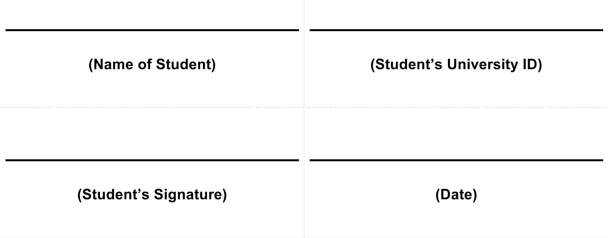

**(Supervisor’s Name)**

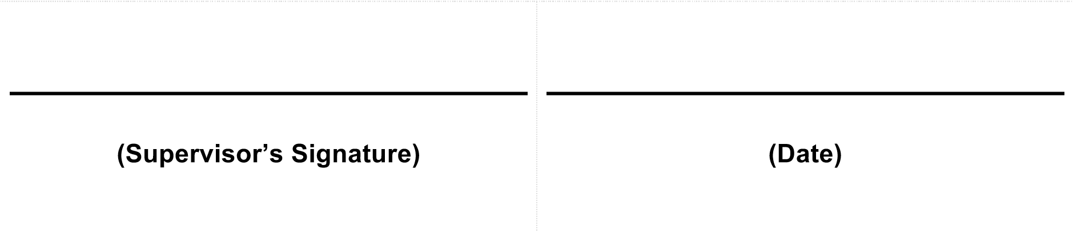

# ACKNOWLEDGEMENT

All Praise to Almighty Allah for giving me the blessing, the strength, the chance and endurance to complete this study.

I would like to express my sincere gratitude to my supervisor, Dr. Forgor Lempogo of Ghana Technology University College (Accra, Ghana), for his patience, enthusiasm, insightful comments, invaluable suggestions, helpful information, practical advice and unceasing ideas which have helped me tremendously at all times in my research and writing this report. I am thankful to him for his precious time in guiding me, answering my queries, correcting and improving the structure and English grammar of my report. Without his guidance and relentless help, this would have not been possible. I could not have imagined having a better supervisor in my study.

I also wish to express my sincere thanks to Coventry University for accepting me into their BSc Computing Science program. In addition, I owe my gratitude to all my colleagues for giving me their company, friendship, moral support and advice. Special thanks, tribute and appreciation to all those their names do not appear here who have contributed to the successful completion of this study. Finally, I am forever indebted to my family who, understanding the importance of this work suffered my hectic working hours, To my mother Hajia Fati Issah, and all my siblings.

Sincere Regards,

Karim Nasir Abdul

TABLE OF CONTENTS

ABSTRACT ii

DECLARATION v

ACKNOWLEDGEMENT vi

TABLE OF FIGURES xi

TABLE OF TABLES xiii

Chapter One: Context and Preliminary Investigation 1

1.1 Introduction 1

1.1.1 Background of Study 1

1.1.2. Problem Definition 3

1.1.3. Aim and Objectives 5

1.2. Scope and Significance of Study 6

1.2.1. Significance of Study 6

1.2.2. Project Scope 6

1.2.3. limitation of Study 8

1.2.4. Organization of Study 8

1.3. Preliminary Literature 9

1.3.1. Introduction 9

1.3.2. History of Candling 9

1.3.3. Moving to the Flashlight System 9

1.3.4. Moving to Commercially Sold “candlers” 10

1.3.4. The Invention of “Hachy-App” 10

1.3.5. Conclusion 11

Chapter Two: Literature Review 12

2.1. Introduction 12

2.2. Overview 12

2.3. Egg Candling 12

2.3.1. History of Candling 15

2.3.3. Importance of candling 16

2.3.2. How Candling is Done 17

2.3.4. The use of information systems for candling 19

2.3.5. Current Trends in candling technology 19

2.3.5. Machine learning and Egg candling 20

2.4. Similar Existing Systems 21

2.4.1 Hachy — Smart Candler for Farmers 21

2.4.2. Microcontroller-Based Egg Candling System 23

2.4.3. A Machine Vision System for Detecting Fertile Eggs in the Incubation Industry 25

2.4.4. ECAT Laser Life Candling 26

2.4.5. Egg Candling Analysis Device 28

Chapter Three: Analysis, Methodology and Design 31

3.1. Introduction 31

3.2. Methodology and System Analysis 31

3.2.1. Fact Analysis 31

3.2.2. Software Development Life Cycle (SDLC) 32

3.3. Project Plan 38

3.4. Requirement Planning Phase 39

3.4.1. Feasibility Studies 39

3.5. Requirements Specifications and Tools 41

3.5.1. Functional Requirements 41

3.5.2. Non-functional Requirements 42

3.5.3. Hardware and Software Requirements 42

3.7 User Design Phase 44

3.7.1. System Architecture 44

3.7.2 Modelling of the Egg Candler Unit 48

3.7.3 Use Case Diagram 50

3.7.4 Sequence Diagram 51

3.7.5 Activity Diagram 54

Chapter Four: System Testing and Implementation 56

4.1. Introduction 56

4.2 Construction Phase 56

4.3 Development Tools and Technologies 56

4.3.1 Tools and Materials Used for The Egg Candling Unit 56

4.3.2 Development Tools and Technologies Used for The Android Software 57

4.4 Presentation of System 58

4.4.1 Egg Candling Unit 58

4.4.2 Android App System interface 59

4.5 Testing 61

4.5.1 Testing Process 62

4.5.2 Requirement Traceability 62

4.5.3 Testing Schedule 62

4.5.4 Testing Strategy 63

4.5.5 Unit Testing 63

4.5.6 Integration Testing 63

4.5.7 User Acceptance Testing 67

4.5.8 Usability Testing 68

Chapter Five: Conclusion and Critical Evaluation 71

5.1. Introduction 71

5.2. Project Outcome 71

5.3. Lessons Learnt 71

5.4. Limitation of the System 72

5.5. Recommendations 72

Reference 74

Appendixes 82

# TABLE OF FIGURES

Figure ‎2.1 Egg candling (Solway, 2015) 14

Figure ‎2.2 Chicken Egg Developemt Candling (Backyard Chickens, n.d.) 15

Figure ‎2.3 Architecture of Hachy — Smart Egg Candler (Eugene, 2018) 22

Figure ‎2.4 Block Diagram of a Complete hatching Machine (Akanji and Jibia, 2015) 23

Figure ‎2.5 Flow chart for the egg candling unit (Akanji and Jibia, 2015) 24

Figure ‎2.6 A Laboratory Size Auto-candling machine (Hashemzadeh and Farajzadeh, 2016) 25

Figure ‎2.7 ECAT - ECAT Laser Life Candling - Eggs Candling (ECAT, n.d) 27

Figure ‎2.8 Upper view of the individual cavity of the conveyor chain (Varga et el. 2018) 29

Figure ‎2.9 Graphical User Interface of the System’s Software (Varga et el. 2018) 30

Figure ‎3.1 Phases of Rapid Application Development (Newgenapps, 2017) 35

Figure ‎3.2 The level of Factors For Which Software Development Methodology is Appropriate (GAVRILĂ et al. 2011) 38

Figure ‎3.3 System Architecture (Author’s Design, 2020) 46

Figure ‎3.4 Egg Candler Unit Model (Author’s Design, 2020) 49

Figure ‎3.5 Egg Candler Unit Circuit Diagram (Author's Design, 2020) 50

Figure ‎3.6 Use Case DIagram of the Smart Egg Candling System (Author’s Design, 2020) 51

Figure ‎3.7 Egg stage prediction Sequence Diagram (Author's Design, 2020) 52

Figure ‎3.8 Sequence Diagram for Obtaining Egg Stage Results (Author’s Design, 2020) 52

Figure ‎3.9 Sequence Diagram for Eggs Scan (Author's Design, 2020) 53

Figure ‎3.10 User Illumination of Eggs Sequence Diagram (Author’s Design, 2020) 53

Figure ‎3.11 Egg Candling Unit Setup Activty Diagram (Author’s Design, 2020) 54

Figure ‎3.12 Mobile App First Time launch Activity Diagram (Author’s Design, 2020) 55

Figure ‎4.1 The Egg Candler Unit (Authors Design, 2020) 58

Figure ‎4.2 Reflector and LED of The Egg Candling Unit (Authors Design, 2020) 59

Figure ‎4.3 Graphical User Interface of the Android App (Author’s Design, 2020) 60

Figure ‎4.4 Graphical User Interface of the Android App (Author’s Design, 2020) 61

Figure ‎4.5 Chicken Egg On Rubber Ring (Author's Design, 2020) 64

Figure ‎4.6 Egg Candling Image (Author’s Design, 2020) 65

Figure ‎4.7 Screenshot of Azure Custom Vision Site (Author’s Design, 2020) 66

Figure ‎4.8 SUS usability Test Results Summary for the Smart Egg Candling System (Author’s Design, 2020) 69

# TABLE OF TABLES

Table ‎3.1 Project Plan 36

# Chapter One: Context and Preliminary Investigation

## 1.1 Introduction

The introduction is the first section that clearly outlines the purpose and relevance of this document. It gives a brief description of the project background, identifies the problem to be solved, and states the goals and objectives of the identifying problem. This section serves as a roadmap to the project plan, scope as well as the entire content of the project.

### 1.1.1 Background of Study

In Ghana, livestock production is a major source of income for farmers and accounts for 14% of the agricultural GDP (Bagbara n.d.).

According to a survey by MOFA/DFID (2002), the livestock/poultry component serves as a ‘safety net’ providing an essential source of ready cash for emergency needs. Thus, even though livestock and poultry contribute only 7 percent to the agricultural GNP their role in rural livelihoods and food security is important (FASDEP 2002).

FAO’s 2013 report suggests that, much of the operations in the poultry sector are focused on producing hen table eggs. The National Poultry Census of 2009 revealed 59% of the total population of poultry were layers. As there is less to no importation of table eggs into the country, consumers rely only on locally produced eggs (Anthony 2013).

Also, A recent research conducted by Amplifies Ghana, an institution promoting the consumption of egg, has revealed that the consumption of eggs in Ghana has increased accounting to the need for increase in the production of eggs as well as livestock (Larnyoh 2018).

An estimated number of layers and eggs production on 10 selected farms at Volta in 2013 implies that, average laying percentage per hen housed at the peak of lay, ranges between 60%-85%. However, poor management and handling of eggs could reduce production to as low as 20%-50% (Anthony 2013).

Biologically, eggs when laid after almost 20 hours of fertilization undergo few chicken - egg developmental stages which is worth noticing. The egg laying is followed by cleavage, which is also followed by gastrulation, then organogenesis which eventually leads to hatching of the chicken eggs. Once the egg hatches with a baby chick, the outer development continues and the chick changes to a hen (Farhan 2013).

However, when it comes to eggs, a farmer can’t be 100% sure of whether or not an egg will hatch. Some fertilized eggs stop developing during incubating while other supposed fertilized eggs did not even get fertilized. These eggs are known as “quitters” and “yolkers” respectively. The “winners” are those properly fertilized developing eggs (QC Supply 2018).

It is very important for a farmer to remove quitters and yolkers from the incubator because they will rot. While rotting, the eggs builds up gas and explode if left in the humidity of the incubator. Not only will this be a smelly mess, it exposes the good eggs to bacteria. For such reasons, farmers candle their eggs to remove them (QC Supply 2018).

Candling got its name from the olden days where people used candles as source of light to candle eggs to view it content. It is of course possible to buy or make a “Candler” these days using a light bulb or a bright torch as the source of light (Daniels 2018).

Some farmers candle to check the status of their eggs as often as daily while others check as little as 2 times until the egg hatches. From an experiment, it was found that an egg will take about 40 seconds to 1 minutes for candling which will be very inefficient in cases where eggs are many.

### 1.1.2. Problem Definition

Indeed, the poultry sector has continued to grow and industrialize in many parts of the world. An increasing human population, greater purchasing power and urbanization have been strong drivers of growth. Advances in breeding have given rise to birds that meet specialized purposes and are increasingly productive, but need expert management.

Poultry is of great economic importance because, it provides people with eggs and meat for daily consumption. it is also a major source of revenue for farmers in Ghana. Also, its socio-economic value and importance in reducing rural poverty and betterment of the society cannot be overlooked (Bagbara n.d.).

It therefore behoves on every individual, whether government or citizen to support and contribute to developing a productive, more profitable livestock sector that revitalizes the broiler industry, increases domestic production, decreases the importation of livestock products and create jobs to boost the overall economy as well as the living condition of individuals in Ghana.

This is only achievable when the marketing system is efficient. According to Widyanugraha (2019), disease, suboptimal management practices and reduced egg production are the top three problems in the layer sector, all of which can result in lower income for producers. He made it clear that preventing these factors will improve the production and profitability of eggs in layer units.

Considering the above facts, more eggs actually leads to efficiency in the poultry sector. Whether the poultry farmer is rearing for commercial egg production or for hatching, egg is important. Eggs need to be fertile in order for hatching to occur. Generally fertilized eggs are mostly ordered from a hatchery or from poultry farmers with roosters in their flocks.

In incubating eggs, the farmer sets an incubator. Once the incubator is set-up, the farmer places eggs inside the incubator. This process is termed as “setting the eggs”. When the eggs are set, the incubation process begins. An important part of this process is turning, or rotating, the eggs between day 1 -18 of incubation. Around day 7 - 10, farmers candle their eggs to determine the progress of the embryos (Mikelle Roeder n.d.). Cases where this candling process is not exercised carefully, a great loss could occur.

From close observation, it usually takes a farmer 40sec – 1min to candle an egg which is really discouraging. Imagine a situation where eggs are in their numbers, like hundreds or thousands?

Again, it is quite clear that not all poultry farmers incubating eggs are expert in candling since there considerable number of individuals who joined the poultry business not long ago (Andrews n.d.). With the name of candling, some poultry farmers destroy the embryos of their eggs, others lose their fertilized eggs to the ground. Hence reducing the overall production of the poultry sector.

Furthermore, large number of shoppers at farmers' market who routinely shop for fresh organic eggs find it a hassle to pick eggs and candle them one by one. They end up buying eggs that are not fertilized or eggs that lack the qualities for hatching. Thus, causing a huge loss on the side of the farmer.

Also, Individuals who are new to poultry invest weeks of learning before becoming experts at candling eggs to check the progress or developmental status of the egg. Therefore, creating a kind of “barrier-to-entry” in the poultry sector, specifically egg hatching.

### 1.1.3. Aim and Objectives

#### 1.1.3.1. Aim

The aim of the project is:

* To develop a super-fast smart egg candling technology.

#### 1.1.3.2. Objectives

The project has the following objectives:

* Study exiting candling systems
* Design and model an efficient candling system
* Build a graphically user-friendly application
* Use Image Recognition Service provided by Azure to determine the development of an egg
* Embed machine learning models in the Android application using TensorFlow Lite
* Implement the app using Java programming language

## 1.2. Scope and Significance of Study

### 1.2.1. Significance of Study

The findings of this study will redound to the benefit of the society considering the fact that, poultry contributes to 14% of the agricultural GDP. The large demand for poultry which is estimated to be about 400,000Mt justifies the need for much concentration and improvement in the poultry sector (Bagbara n.d.). Thus, farmers that adapt to the proposed candling technological approach, from the result of this study, will be able to increase the production of eggs in their poultry farms which will be of great benefit to the farmer as well as the whole country.

Individuals or shoppers at farmers' market who routinely shop for fresh organic eggs but find it a hassle to pick eggs and candle them one by one will equally benefit from this study. Also, this study benefits individuals who are into poultry but have low knowledge on how to candle and analyse an egg manually to view it progress (Andrews n.d.). Money, Time and Energy of poultry farmers are key factors which will be preserved in the adaptation and usage of the study.

### 1.2.2. Project Scope

This project is about building a smart egg candling technology for farmers in Ghana as well as the world. The project features an android application that relies on just a phone’s camera to candle an egg. User interface is designed as part of the project but contains, as a minimum, the ability to scan an egg to determine the classification of the egg (Anthony 2013).

Eggs are classified into 3 stages: “Egg_early” which implies no development in the egg, “Egg_mid” which indicates an egg to be developing with a visible zygote and “Egg_late”, which also indicates that the egg is matured with visible blood lines and other organs (Farhan 2013).

#### 1.2.2.1. Expected Outcomes

The following outcomes are to be expected at the end of the project:

* User should be able to check the status of an egg
* User should be able to candle an egg as fast as 3-5 seconds
* User should be able to use the system even when there is no internet
* User should be able to have interactions with the system without any technical or IT background

#### 1.2.2.2. Project Boundaries

For a perfect experience of the application, the candling egg should have a darker background with a yellowish light sphere. Internet is not a “must-have” requirement to get the application running. The App is limited to checking an egg at a time but is keen to speeding up the whole candling process. Android phones with minimum API levels of 19 or above is recommended.

#### 1.2.2.3. Project Deliverables

At the completion of this project, the following items will be delivered to the assessment board:

* Executable and non-executable versions of the artefact
* A softcopy of project report
* 2 printed copies of the project report

### 1.2.3. limitation of Study

The limitation of this project includes but not limited to:

* The study is not a new concept but a modification of existing concepts using modern technology available
* Integration of a third-party’s API that may demand charges
* limited to candling an egg at a time
* There are also exceptions to data recognition as well

### 1.2.4. Organization of Study

This thesis will be organised into five chapters.

To begin with, Chapter One will introduce and discuss the background of the study, outline it problems and state the aim and objectives of the study. Chapter one will also state the project scope as well as its significance of the study.

Chapter Two will be a comprehensive literature review of a concise overview of what has been studied, argued, developed and established about the topic.

The Chapter Three of the study focuses on the analysis, methodology and design used to implement the project. This chapter will go deeply into the type of methodology used for the project, why and how the specific methodology was selected as suitable for the project. The means of analysis of the problem down to the choice of methodology will be explicitly elaborated. The design and diagrams are not left out in this chapter.

Next, Chapter Four will explain the method of implementation used, the development tools used and why, graphical snapshots of key parts of the functional artefact, testing means used and explanation of how it was done.

Finally, Chapter Five concludes the entire project. This part involves project evaluation; what was learnt, what could be done differently, any additional features that can be implemented and the value of what has been learned and achieved.

## 1.3. Preliminary Literature

### 1.3.1. Introduction

This chapter discusses several texts for the purpose of establishing the fundamental egg candling technology. Several arguments have been made and addressed to allow a faster and less human involvement in the candling and checking of eggs.

### 1.3.2. History of Candling

Andrews (n.d.) argued in his paper that, the way older people used to hatch their chicks before was by "candling". He stated in his article that, candles were then used, hence the name “candling”. Regarding to the “how” of the process, he said it was done in a darkened room where incubated eggs were kept over flames to allow individuals to see through the shell of the egg.

But was this process of theirs Ideal? No, definitely not. The problem with using the candle was that, they were unstable-and very hot. The last thing a farmer would want to do to a fertile egg is to cook it (Andrews n.d.). It was very slow and kind of difficult to analyse an egg since the light wasn’t that bright. Candles had their disadvantages and are not used in modern hatching.

### 1.3.3. Moving to the Flashlight System

Flashlights were certainly a step in the right direction, not as hot and a lot more stable. Even now, some farmers use flashlight for candling. A strong light and either a home-made box or hand made into a fist was okay. Was flashlight just perfect? No, not really (Andrews n.d.).

Flashlight also had its own drawbacks. The light tends to be less intense, since some of the lights were absorbed by the hand. It was also very easy to drop an egg balanced on a fist, especially if simultaneously trying to take photographs (Andrews n.d.). It was again very slow like its predecessor and everything regarding to the analyzing of the egg to check its progress was done manually.

### 1.3.4. Moving to Commercially Sold “candlers”

A further move was made towards Commercially sold “candlers” which is the modern equivalent of the torch and the candle and was much easier to use. Powered by batteries, the light of this “candler” wasn't hot, but strong enough to give a great view through the shell, especially when used in a darkened room. Using it with an 'ovascope' brought about a perfect combination (Andrews n.d.).

However, this move also saw some percentage of farmers left behind. Commercially sold “candlers” were too expensive to purchase and did not even do the hard work of analyzing the egg for farmers automatically. Farmers wanted something much simpler but can do all the hard work.

### 1.3.4. The Invention of “Hachy-App”

Recently, a step was made in bringing back the remaining percentage of farmers behind. Market saw a system which relied on both web-based application and an android app called “hachy” which candled eggs at a pretty effective way. In a demonstration of the system on YouTube, Eugene scanned three eggs in a “Hachy-Box” one after the other. He used an android app that took pictures and uploaded them to Azure server (2018). The server then classified the image and sends a respond back to the mobile app and website respectively. Hence, discouraging the need for individuals to fetch eggs, candle, and analyze development manually (Eugene 2018).

The System implementation and efficiency of usage mattered. It was difficult to implement the overall project in respect to the number of resources needed. The system needed a laptop, internet and many more. Using his Android App, a picture of an egg needed to be taken first which will be uploaded to Azure server for classification, brought back to the phone and laptop for viewing which is inefficient. While watching Eugene on YouTube, questions like this came up: How many farmers could afford the implementation of this system? What would the status of the system be when there is no internet available? Can response of the status of the egg be faster than this?

### 1.3.5. Conclusion

This concludes the several texts established in the fundamental egg candling technology. Several issues were addressed to allow the implementation of this study. Comparisons were made to justify the state of already existing systems.

# Chapter Two: Literature Review

## 2.1. Introduction

This chapter will review studied literature on the subject topic that revolves around news, information, social media and effective management of said resources. As a significant venture, this segment has numerous subtopics under it to help give the study better illumination.

## 2.2. Overview

Today, nearly 60,000 million chickens are fattened annually and 4,500 million hens lay more than 300 million tens of eggs a day. An industry of this kind undoubtedly needs a high level of technology, both in the genetics of the birds themselves, and in their nutrition (HIPRA n.d.). That said, different kind of technology have been developed over the years to help revitalize the incubating industry.

This report provides an overview on egg candling. It elaborates on the use of information systems to candle chicken eggs as well as how machine learning can improve the existing candling systems.

The primary resources for these analyses include many reports prepared in response to the efficient and fast candling of an egg, which may review and explain some of the proses in the available literature.

## 2.3. Egg Candling

The translucency of many avian eggs makes them perfect for candling, a technique used to observe the growth and development of an embryo inside an egg (Delany et el. 1999).

According to Arcuri (2019), the act of holding a light or candle near an egg to see its inner contents is termed "Candling". It can be used to check if an egg is fertile or not. Looking at the egg content color, shape, and opacity will help a farmer decide whether a chick is inside or not.

Delany et el. (1999) stated that, a perfect candling technique, coupled with knowledge of abnormal and normal features of an avian egg and embryo, can provide vital information on the nutritional, genetic, and reproductive status of breeding birds, as well as information on the developmental progress and success of individual embryos”.

White-light candling is increasingly used by aviculturists, exotic bird breeders, and avian veterinarians for examining eggs of altricial species such as parrots (Delany et el. 1999), and precocial ones such as chicken, duck and many more. However, only few training aids are available to acquire candling skills.

Currently, candling is used in modern commercial egg production primarily to rate the quality of eggs (Encyclopædia Britannica 2020). Below is Figure 2.1 demonstrating candling.

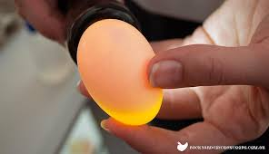

Figure ‎2.1 Egg candling (Solway, 2015)

In Georgia for instance, all chicken eggs must be evaluated by a certified grader, and appropriately packaged and labeled in accordance with the Georgia Egg Law and Georgia Food Act before it can be sold (Maddy 2016).

To be able to sell eggs to a restaurant, a grocery store, or bakery, the Georgia Department of Agriculture (GDOA) must have licensed the farmer’s candling facility. The no-cost, lifetime certificate is obtained by passing both written and hands-on candling examinations (Maddy 2016).

Apart from Georgia State in the USA, countries Like Italy, United Kingdom (UK) and many more also have their own laws regarding egg sales and marketing – in terms of candling wise. Ghana is yet to enact a law like that though candling is still being conducted.

Moreover, since this paper is driven at chicken-type of candling, it is important to note the various stages a chicken egg passes through to hatching. Figure 2.2 below shows the various stages of a chicken egg.

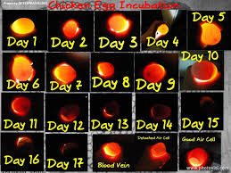

Figure ‎2.2 Chicken Egg Developemt Candling (Backyard Chickens, n.d.)

### 2.3.1. History of Candling

In early days before electricity, candles were used to illuminate eggs (Maddy 2016). Eggs were held over flames in darkened rooms to allow vision through the shell of the eggs, hence the name “candling” (Cocks Machine n.d.). But for reasons such as, heating up of eggs embryos, possible accidents and many more, a shift was made to the use of flashlight.

Since the introduction of flashlights, there have been advancement in the direction of electrical candlers like the DIY egg candlers, Home-made box candlers, commercially made candlers and many more.

It is worth knowing that, the history of candling may vary according to different sources. While some sources may claim candling to have begun with the use of sun shine, where eggs are placed against window shutter openings, or holes in walls of a darkened room located on the sunny side of a building to see through them (Delany et al. 1999: 116), others may report candling to have begun with the use of candles (Maddy 2016; Cocks Machine n.d.; Andrew n.d.). All the same, candling is now a well-established technique and not even its history can change that.

A detail discussion on the history of candling can be found in chapter one, section *1.3.2. History of Candling* of this document.

### 2.3.3. Importance of candling

Egg candling is vital because it helps farmers or individuals keep track of all kinds of problems in the incubation timeline. Not only is it possible to use candling for tracking fertility issues – it can be used to identify which eggs are fertilized early on – or observe problems such as halted embryo development and late mortalities inside the shell of an egg. Candling can also help in the determination of the hatchability of a shipped hatching egg (Pierce 2016).

In the case of shipped eggs, it is recommended to candle them before putting them in the incubator. This way, it is possible to get a closer look at a small hairline crack (Pierce 2016).

Sometimes, an eggs embryo stops developing very early in the incubation process. Hence, if eggs are candle within the first couple of weeks, and a thick red line is noticed, it informs whoever is doing the candling that, the chick will not make it to hatching. This is known as a bloodline, and it’s a sign that your chick has died (Andrew n.d).

Other embryos fail to mature further during the egg incubation process which is alarming. Sometimes, it is possible to determine the cause of the death embryos by looking at the eggs either through candling or cracking it open – the latter Is not recommended due to smell or bacterial infections (Pierce 2016).

### 2.3.2. How Candling is Done

It can be very quick to candle eggs and find out if chicks are coming along perfectly. Candling does not harm eggs as long as the light source used doesn’t heat the eggs, and the eggs are not kept out of the incubator for a long time (Terry n.d.).

##### 2.3.2.1. Candling equipment

Candling can either be done using a small basic flashlight, or an expensive high-end machine. Of course the chance of accuracy of the candling result tally with the amount of money invested in the candler. Thus, more money, more accuracy. However, it’s possible to get a good handle on what’s going on inside eggs without purchasing a costly machine (Pierce n.d.).

Some candlers contain high-intensity webcams, while others have viewing lenses or adapters for different size eggs. Though, it’s is possible to fashion an old DIY candler by attaching a bit of cardboard to an LED flashlight to candle eggs (Pierce n.d.).

##### 2.3.2.2 Candling Technique

When it comes to candling, it is preferable to practice it in a completely dark room. Candling is exercised as follows:

An egg is to be held up against a light source. Preferably, the light source should be placed against the side of the egg, for the reason being that, the air sac that helps in determining the state of the egg develops on the larger rounder portion of the egg. Where necessary, the egg must be rotated until the clearest possible view is obtained (QC Supply 2018).

##### 2.3.2.3 Egg Identification

Although the below is not a must-do in candling. It is being presented in this study to prove the fact of a full candling technique. Eggs are sometimes candled to identify, or study other things rather than what is presented below. The presented one is the most common though.

With a clear view of the inside of the egg, the next is identifying whether the egg is a winner, a quitter or a yolker. A winner is an egg, successfully developed into an embryo. A network of white blood vessels with a dark outline at the centre indicates a winner. Depending on the egg’s development, it may be possible to observe the dark eyes of the embryo or the slight movement of the embryo (Hudson n.d.).

For quitters, there’s a red circle on the inside of the shell. Meaning, the embryo began to develop but died at some point thereafter. An egg which was never fertilized is a yolker. It is determined by eggs that gives off sheer glow—no dark spots, no blood vessels, no streaking (Hudson n.d.).

Per candling principles, quitters and yolkers when discovered, are tossed out of the incubator to prevent any chance of rot (QC Supply 2018).

### 2.3.4. The use of information systems for candling

Current developments in technology and mathematical modelling has open new possibilities for real-time automatic monitoring of eggs. New technological innovations that are potentially adaptable to commercial candling of eggs, are appearing. Though their practical implementation is still being defined (Neila et al. 2016).

The adaptation of information systems in the candling of egg is no doubt a right step to the right direction. Information system may offer an advanced and quick way of candling eggs. Egg candling, which when done manually would take an average of 40 seconds, can be reduces to as low as 4 seconds (Eugene 2018).

Information systems have the potential to improve candling as well as optimize the egg incubation process of a farmer. Therefore, improving candling in the direction of information system only brings about efficiency in terms of use of resources. Thus, time, money, energy and long-term sustainability.

### 2.3.5. Current Trends in candling technology

In the last few years’ tremendous advances were achieved in egg candling technology in terms of diversity, accuracy, and affordability. Automated systems have been developed for inspecting eggs in large quantities (Hashemzadeh & Farajzadeh, 2016). The new age has seen candlers made with micro controllers, smartphones, and many more.

According to Incubator Warehouse (n.d.), dealers in egg candling devices, commonly used candlers are of two types:

* Candlers that uses AC power, where a chord is plugged into wall outlets to turn on the bulb. An example is the “Magic fly Bright Cool LED Light Egg Candler Tester”, which is reviewed to be the best candler (Burris 2019).
* The second type, which is similar to a flashlight uses high-density LED bulbs. The end of the light is modified to allow an egg fit tightly onto it so that no light escapes from the seam between the egg and the egg candler. “Titan Incubators High-Intensity Egg Candler for All Egg Types” is an example (Burris 2019).

### 2.3.5. Machine learning and Egg candling

Seen as a subset of artificial intelligence, machine learning, which is a computational method used in data mining tasks such as clustering, classification and prediction, has developed in recent years (Juhola 2015). Various works have been done based on machine learning to perform many tasks in the incubating industry.

Egg Candling is of no exception. Machine learning technology have been employed in egg candling to classify eggs in different ways till date. With machine learning, some researches conducted have focused on the detection of cracks and dirts on eggs (Patel 1998), and measuring of physical coordinates of eggs (Lawrence 2008).

Machine learning have already shown or depicted the capabilities of speeding up work in the egg candling processes of the incubation industry. Candling systems like the micro-based egg candling systems, and many more, have been developed using machine vision techniques, a subset of machine learning, which has been a benefit to the incubating industry in many ways.

## 2.4. Similar Existing Systems

This section evaluates some existing systems similar to the proposed system. In the context of the proposed system, comparisons will be made.

### 2.4.1 Hachy — Smart Candler for Farmers

The below is and extract taken from the Medium website page of Eugene R. Wang (2018), a student from the University of Waterloo in Canada, who solely developed the “Hachy – Smart candler for farmers”.

“Hachy is a mobile app that uses an image classifier hosted on Azure customview.ai to scan eggs that are being placed inside of the Hachybox. The HachyBox is a box made of cardbox used for insulating internal lightning away from external light to create a closed system of light”.

A clear description of what the application does is given in the extract. From the above extract, the system is only a projection of home-made candler box, of course with a mobile app improvement. The Key function of the Hachy- Smart Candler For Farmers are:

* Reduce the skills requirement for consumers to shop egg
* Provide an easy way to identify the development status of the egg
* Reduce the time used for egg candling.

The architecture model of the hachy app is presented in Figure 2.3 below, depicting how the system works technically.

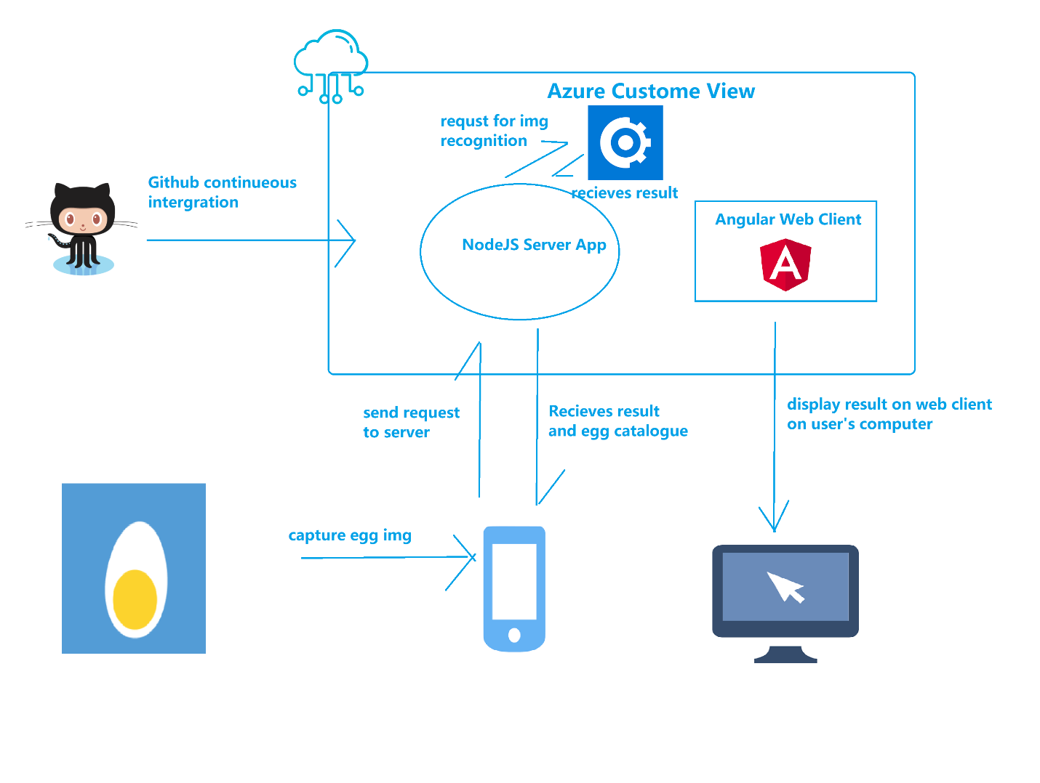

Figure ‎2.3 Architecture of Hachy — Smart Egg Candler (Eugene, 2018)

This system is particularly very useful because it is user friendly, it speeds up the work and above all, it is considered as the first of its kind. On the other hand, many users complained about the fact that, they could not afford to buy mobile data since most resources of the app relies in the cloud, a careful study of the architecture shows that. Where there is no network, or probably network is slow, users found it difficult to use the app. The prediction accuracy of the app is also something that can be improved.

Currently, the system is not in usage. Farmers want something new that can cut cost and operate at even a faster way. Easy, and few steps to attain candling goals is what an efficient candler should do.

### 2.4.2. Microcontroller-Based Egg Candling System

Akanji and Jibia (2015), from the Sokoto State Polytechnic and Byero University of Kano, Nigeria, presents a microcontroller-based egg candling system for candling. The system is a part, or a section of a complete microcontroller-based multicompartment hatching system as shown in a block diagram in Figure 2.4 below:

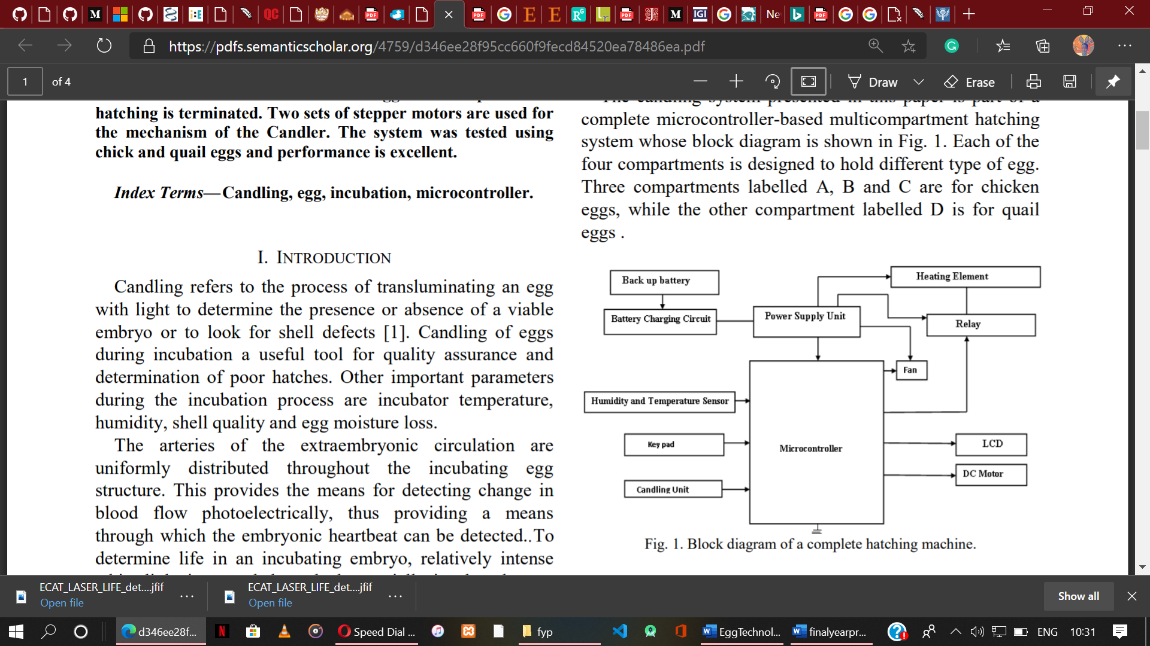

Figure ‎2.4 Block Diagram of a Complete hatching Machine (Akanji and Jibia, 2015)

In bloat, the system design utilizes an IR transmitter and a highly sensitive TSOP receiver. “A 40 KHz signal is passed through a partially incubated egg and received at the other end. Distortion in the frequency of the received signal indicates the presence of a live embryo indicating that the process of hatching should continue. An undistorted signal indicates the absence of life in the egg and the process of hatching is terminated. Two sets of stepper motors are used for the mechanism of the Candler” (Akanji and Jibia 2015).

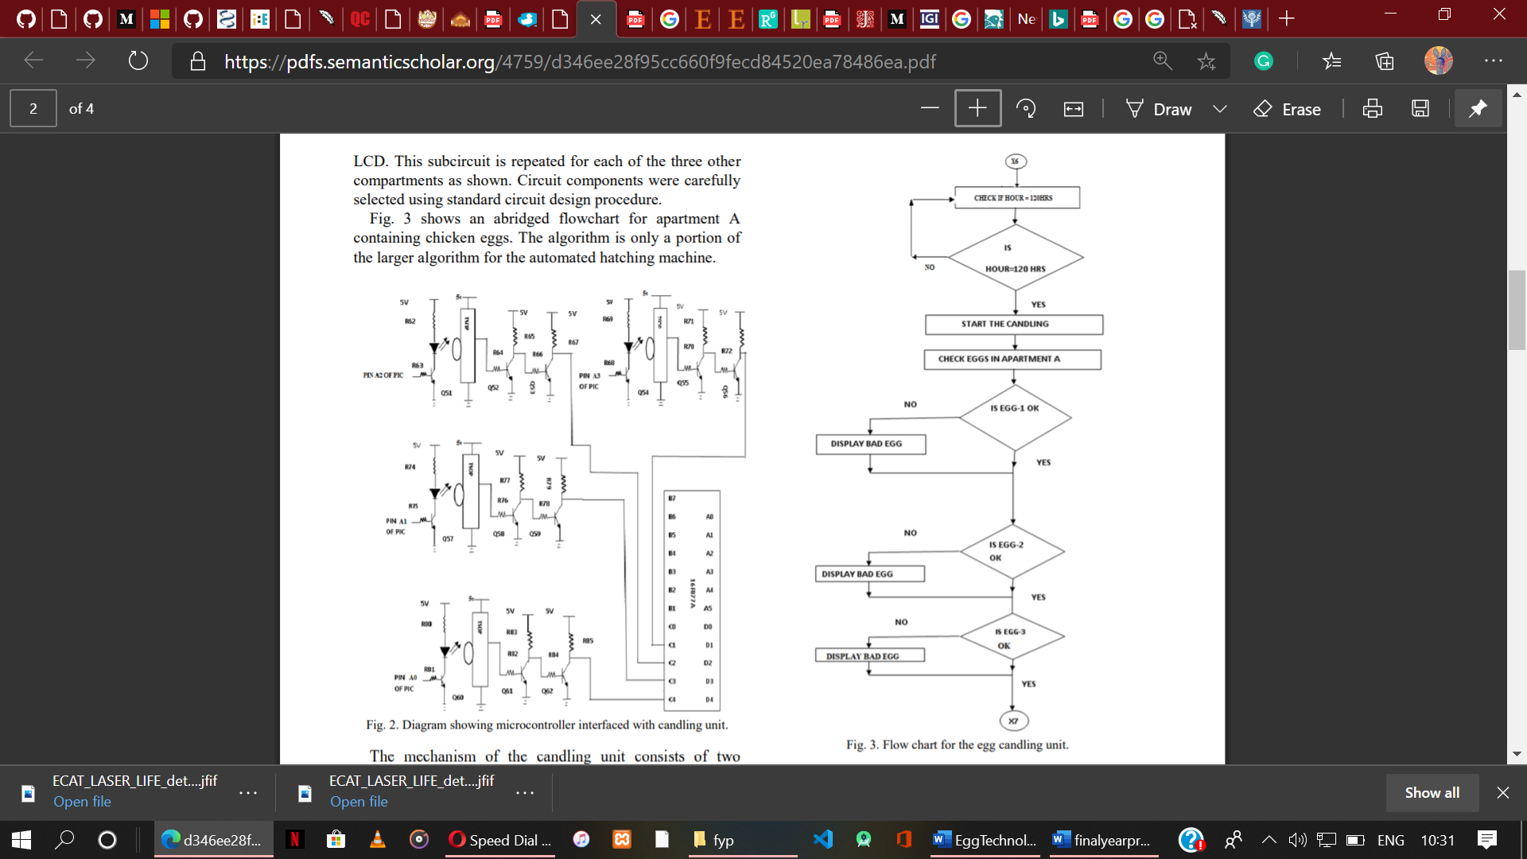

Figure ‎2.5 Flow chart for the egg candling unit (Akanji and Jibia, 2015)

Figure 2.5 above depicts an abridged flowchart of an apartment ‘A’ containing chicken eggs. The algorithm is also just a portion of a larger algorithm for the automated hatching machine (Akanji and Jibia 2015).

Although the microcontoller-based egg candling system’s testing results is encouraging (Akanji and Jibia 2015), most farmers may not benefit from it because of its inability to work alone, since it is just a unit of a complete automated hatching machine. Farmers will need to acquire a mother system, which can be very expensive.

Again, where the candler is switched to a public power supply, a standby generator or a car battery, bad performance could be attained. Thus, it needs improvement in the energy supply.

### 2.4.3. A Machine Vision System for Detecting Fertile Eggs in the Incubation Industry

In view of the sensitivity and value of an accurate digital imaging of eggs, Hashemzadeh and Farajzadeh (2016), of the Azerbaijan Shahid Madani University of Iran, developed a mechatronic auto-candling machine for taking images of eggs. A machine vision system, developed to detect the fertile eggs in the incubation industry.

Mechanical part, imaging light source, and an electronic part are the three main parts, making up the machine vision system. Figure 2.6 below shows a laboratory size of the proposed candling machine.

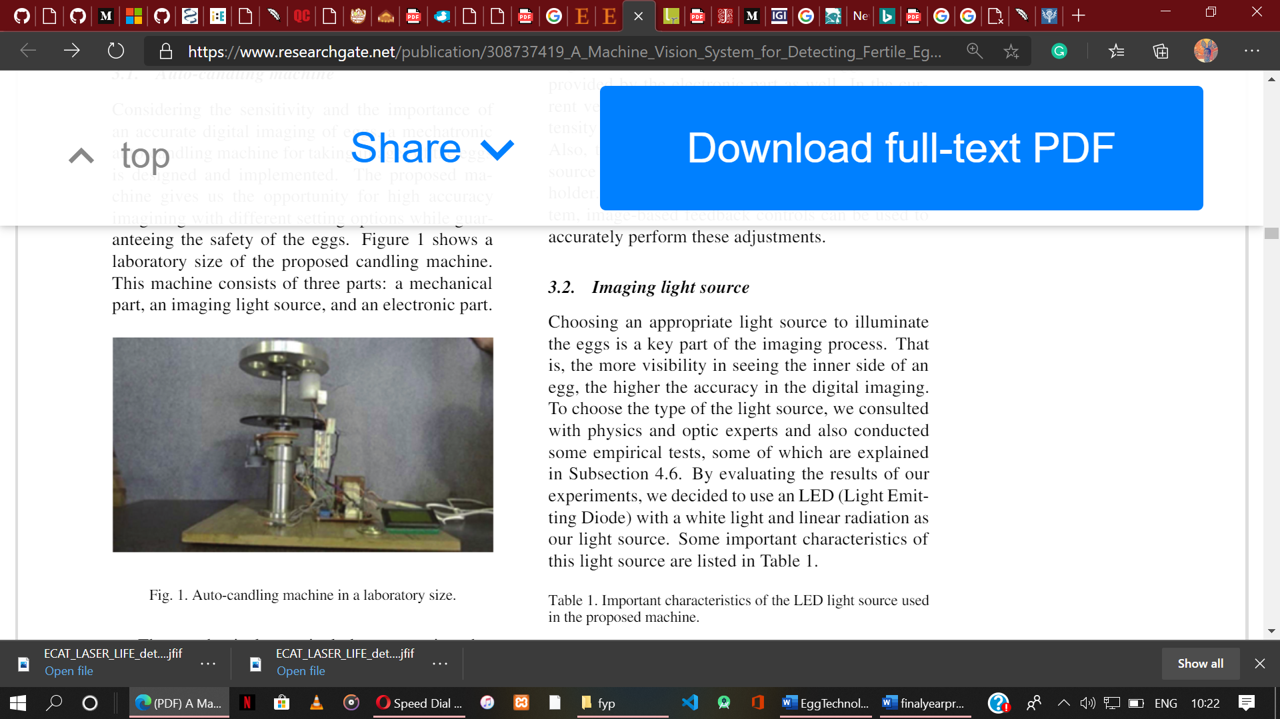

Figure ‎2.6 A Laboratory Size Auto-candling machine (Hashemzadeh and Farajzadeh, 2016)

Technically, the system functions in this manner:

The mechanical part with an engine, moves a platform which has rooms for six eggs. An imaging light source positioned under the platform illuminates the eggs. Next, Imaging process is done by a camera that is ﬁxed next to the eggs in a totally dark environment.

Egg fertility is determined by a fertility detection program on a computer. An electronic part featuring a microcontroller, control relays, optical counter and many more, controls the engine and automatic on/off switching of the light source.

From the egg fertility testing results of the machine vision system (Hashemzadeh and Farajzadeh 2016), the system can be considered good as it serves its purpose. However, the system’s implementation is demanding of too many resources including time and money.

### 2.4.4. ECAT Laser Life Candling

ECAT is a global supplier of hatchery and laboratory automated equipment. It is developed as a commercial candling equipment which currently can be found on the market. No doubt, farmers are their targeted users.

According to the ECAT laser life candling product description on the Poultry-Poultry website (n.d.), it is a technology based on the combination of two complementary elements to candle chicken eggs. Figure 2.7 below shows how the ECAT laser Life Candling looks like.

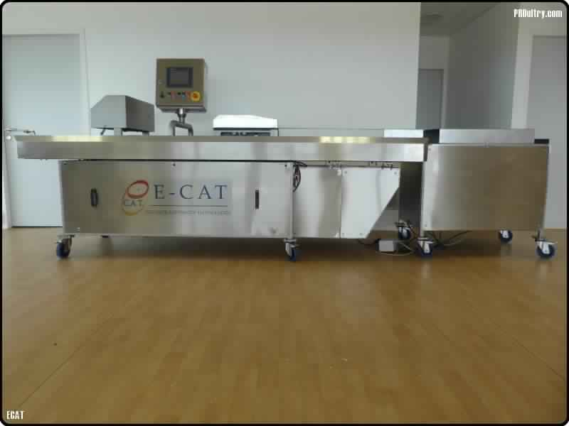

Figure ‎2.7 ECAT - ECAT Laser Life Candling - Eggs Candling (ECAT, n.d)

Some functions of the technology are:

* It uses a laser life to detect incubated, upside down eggs, with an 100% accuracy.
* With the help of a laser beam, the system is able to analyze the volume of an egg and give a differentiated description of its content
* When used with ECAT EGGINJECT especially, it valorizes clear eggs.
* By detecting eggs without touching them, it prevents eggs from many contamination issues and shell cracks.

Although the technology is very useful. Its cost has created a barrier for acquiring. Farmers prefer a system with similar features, but a lot more economical and advanced.

### 2.4.5. Egg Candling Analysis Device

The egg candling analysis device is a technology designed by Varga et el. (2018) for an egg producing factory located in the center area of Ecuador. The device was designed as a result of the concern for occupational safety and health of workers in the factory.

Technically, the design of the egg candling analysis device consists of a conveyor belt with an analysis chamber or classification, which allows cold light to illuminate eggs inside it. Eggs with defects are separated using a mechanism which softly pushes the abnormal samples to the center of the conveyor belt.

Figure 2.8 below shows the upper view of a conveyor chain device which was used for transporting egg.

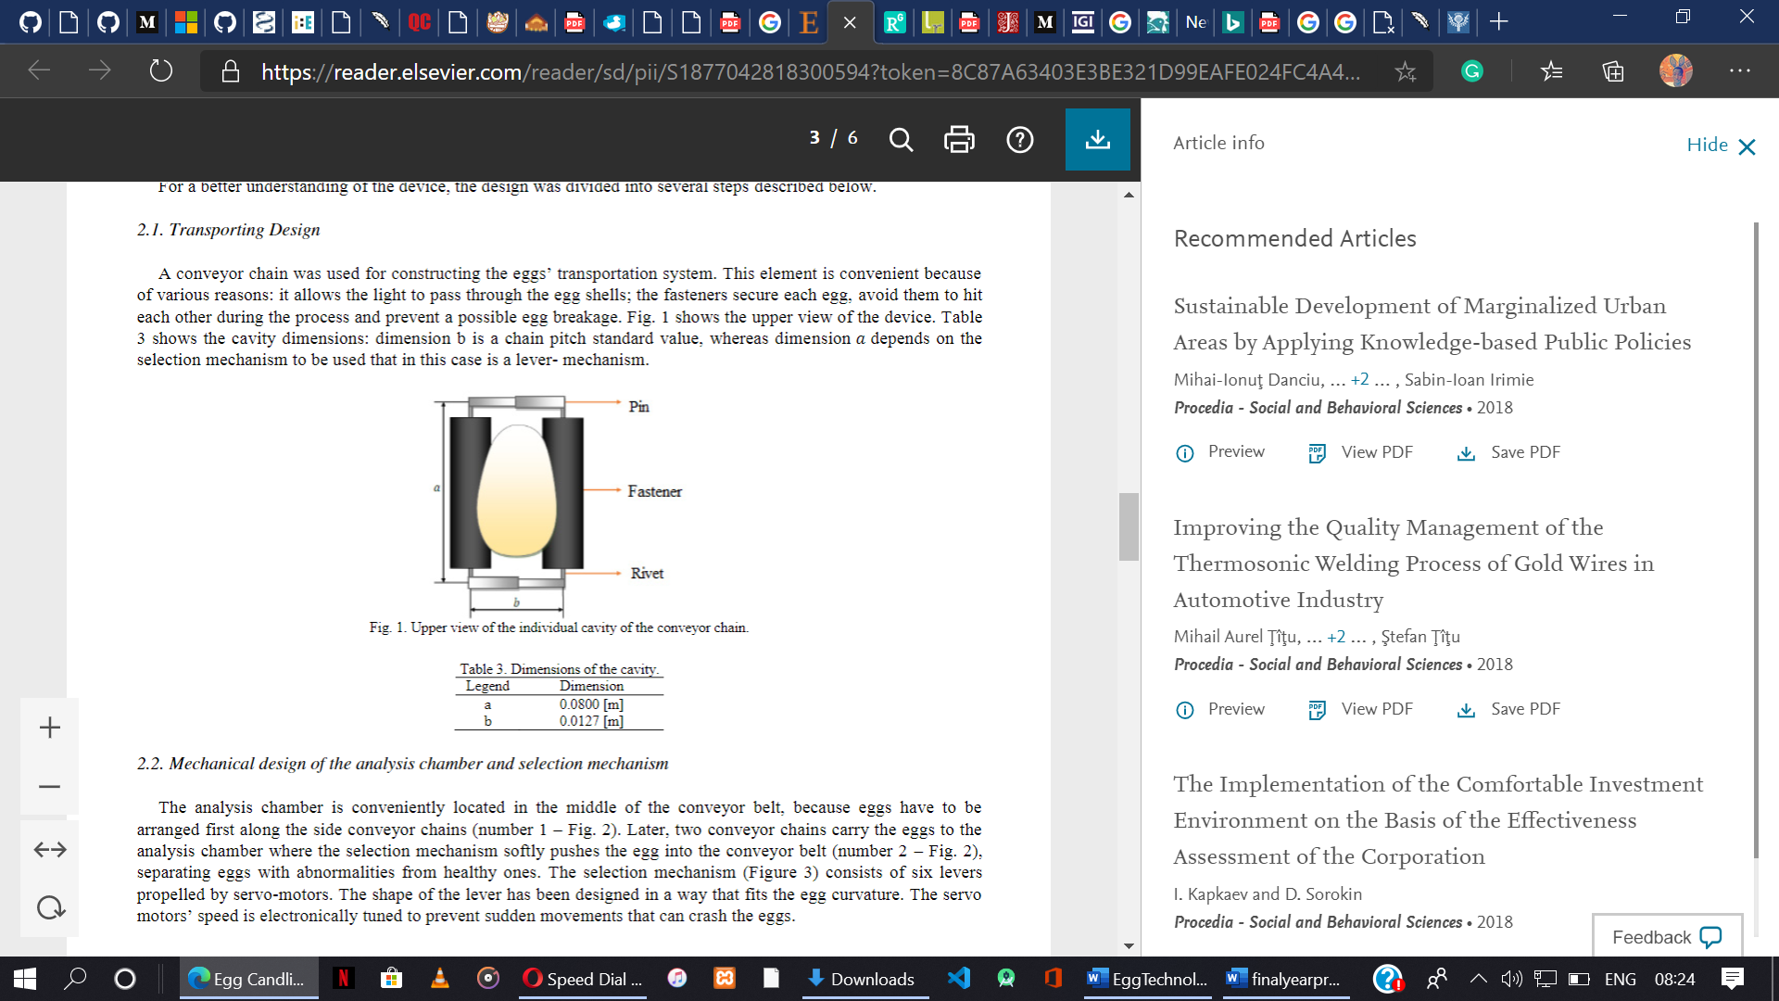

Figure ‎2.8 Upper view of the individual cavity of the conveyor chain (Varga et el. 2018)

With the egg analysis and decision making, a software developed in MatLAB featuring digital image processing is used. As a result, 1000 samples of eggs are reported to have been analyzed and classified with a process effectiveness of 95% (Varga et el. 2018). The Graphical User Interface in Figure 2.9 below shows how the operator visualizes the result of the algorithms featured in the software.

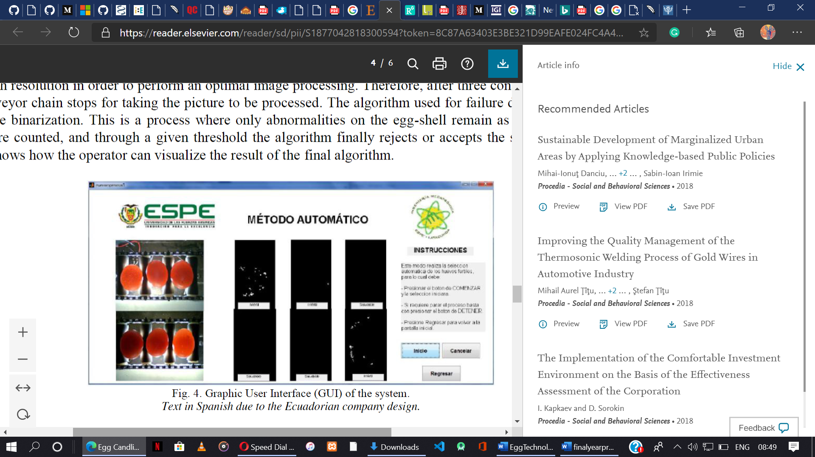

Figure ‎2.9 Graphical User Interface of the System’s Software (Varga et el. 2018)

The software additionally enables a worker to operate the device and classify the eggs by him or herself in manual mode, thus, making the whole system advantageous. However, the cost of the system implementation is high, making it a use-only for big factories and industries.

The above literature clearly demonstrates the need for such a study. However, unlike the systems reviewed, the proposed system will continuously classify eggs from the device’s back camera. The main objectives to be accomplished by the system is to provide a candling system that will classify frames (egg) in real-time with or without the use of internet.

# Chapter Three: Analysis, Methodology and Design

## 3.1. Introduction

This chapter highlights some key information that constitutes the building blocks of the system being developed. This entire chapter will be divided into four sections which coagulate together to form the analysis, methodology and design utilized to create the artefact and all the relevant information concerning it.

## 3.2. Methodology and System Analysis

Without a doubt, a well specified and strictly implemented methodology for managing a project offers a firm guarantee that the project will be completed successful and on schedule (mymanagementguide n.d.). The choice of methodology often heavily depends on the type of project being undertaken. This study discusses and takes into account such methodologies to set out a clear development process path for the proposed system.

### 3.2.1. Fact Analysis

Fact analysis which is also referred to as fact finding in many cases basically refers to information gathering. It is the process of collection of data and information based on techniques such as sampling of existing documents, research, observation, questionnaires, interviews, prototyping and joint requirements planning (UKEssays 2018). Their names are self-explanatory (pc dreams 2017). From among the seven common fact-finding techniques, sampling of existing documents, research and personal observations were the ones implemented in this study to derive at the choice of methodology and also make system specification requirements. Through the results of this exercise, a prototype, which will be shown later in the study, was designed.

### 3.2.2. Software Development Life Cycle (SDLC)

A system development life cycle, or SDLC is a structured project management model that describes the phases required to construct an IT system, from start to finish (intellectsoft 2019). Every hardware or software system goes through a development process which can be thought as an iterative process with multiple phases (Rouse 2019). There are five main phases in any system development life cycle namely planning, analysis, design, implementation, and maintenance of system.

The planning phase is said to be the most crucial stage of the SDLC process. It outlines, identifies and defines the scope of the project. Team structure, timeframe, budget, security, and other fundamental factors are considered here (intellectsoft 2019).

In the analysis phase, existing systems are evaluated. Deficiencies are identified. User’s requirements are extensively analysed. To ensure the system makes sense from both financial and technical points of view, or check for whether it will survive or not, a feasibility study is performed.

The design phase tackles the design of the proposed system’s architecture. Plans concerning the physical design, hardware, operating systems, programming, communications and security issues are laid out (Rouse 2019). Collected data in previous phases are refined into an organised system.

The next phase being the implementation phase, is where the actual coding starts and the programming is built.  The implementation of the design really concerns writing code even though other necessary tasks may arise. In this phase, Developers follow certain predefined coding guidelines. It is worth knowing that all the work at this phase is geared towards the realisation of the system.

At the maintenance phase, requisite adjustments that make for a better user experience can be applied. Whether to improve efficiency, fix bugs, enhance security or resolve user-specific requirements - it is done at this phase (FFIEC n.d.).

It is arguable that, SDLC can be made up of multiple phases like initiation phase, testing phase, even disposal phase. Anywhere from five upwards to 12 phases as argued by Rouse (2019). However, these additional phases which are equally critical for the system's success are integrated into the five highlighted' key' phases mentioned.

#### 3.2.2.1. SDLC Methodologies

SDLC’s or methodologies, in essence, are series of phases or steps through which an organism, or in this context, a software application, goes through in a series of recurrences to arrive at a desired outcome. Having a structure or technique to develop software is fundamental, which explains why there are so many software development methodologies available to choose from (Svitla 2019).

These methodologies include: the waterfall model, spiral methodology, agile software development, iterative and incremental method, lean method, prototyping, Rapid Application Development methodology and many more. Brief descriptions about some of these methodologies is discussed below:

* Waterfall model: Also known as the linear-sequential life cycle model, the Waterfall Model is the earliest SDLC approach used to develop software. Development within the waterfall model is done in a rigid, linear, sequential flow. Meaning, until a phase is completed, there is no progression to another phase. Phases in waterfall model do not overlap (Tutorialspoint n.d.).
* Agile software methodology: With the Agile development approach, software development is based or centred round the idea of iterative development, with requirements and solutions evolving through collaboration among self-organizing cross-functional teams (Cprime n.d.). Unlike the waterfall model, agile prioritises a working software over requirements and design.
* Rapid Application Development (RAD): RAD is a software development approach, focused on fast prototyping and application development. It also focuses on the method of iterative development just like the agile model. RAD put emphasis on software usage and reviews from users over rigid planning and requirement documentation (Capterra 2019).

#### 3.2.2.2. Choice of Methodology

Among all the existing techniques of the system development life cycle, RAD is implemented towards the completion of the technology. Work is being done in incremental prototypes.

##### 3.2.2.2.1 Rapid Application Development

RAD model is a team-based methodology that speeds up and produces system development. Like many other methodologies, RAD model heavily relies on user involvement and prototyping. It allows user examination of the working system as early as possible to determine whether or not, the system meets their needs. Based on feedbacks from users, the developed prototype is modified, and the interactive process continues until system is developed with full user satisfaction. With a four-phase lifecycle that parallels the traditional system development life cycle as the demonstration by Newgenapps in Figure 3 below shows, RAD is a complete methodology.

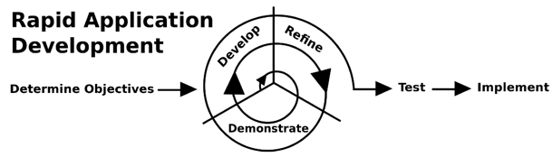

Figure ‎3.1 Phases of Rapid Application Development (Newgenapps, 2017)

Figure 3.1 indicates that, there are four phases in the RAD methodology namely: Requirement Planning (Determine Objectives), User Design (Demonstrate, Develop and Refine), Construction (Test) and Cutover (Implement) respectively. The figure notes the iteration at the user design phase, also known as prototyping phase, which forms the basis of the RAD.

The James Martin Approach divides project development into four distinct phases. These are:

* Requirement Planning Phase: In this phase, IT staffs, Managers and System Users discuss and agree on business needs, scope of the project, system constraints, and requirements of the system. The requirements planning phase must result in an action diagram as well as list of entities that defines the interaction between data elements and processes and should last for about one to four weeks. Ideally, requirements should be captured in a structured tool rather than an unstructured document (BlueInk 2013). This phase ends when the team decides on the main issues and receives management approval to proceed.
* User Design Phase: During this phase, User needs are typically translated into working models. Interaction between users and system analyst allows building of prototypes and models to represent all system processes, inputs, and outputs. User Design is a continuous interactive process that allows users to understand, modify, and ultimately approve a working model of the system that meets their needs (BlueInk 2013).
* Construction Phase: The construction phase focuses on SDLC-like application development tasks and programs. However, users continue to participate in RAD and can still make modifications. Users can suggest improvements or changes as actual screens or reports are being developed. Programming and application development, coding, unit integration and system integration are task that occur in this phase (BlueInk 2013).
* Cutover Phase: The cutover phase resembles the final tasks in the system development life cycle implementation, including the conversion of data, testing, changeover to new systems, and user training. Compared with traditional methods, the entire process is compressed. As a result, the new system is built, delivered, and placed in operation much sooner (BlueInk 2013; Joshi 2019). When compared to the traditional approach, RAD compresses the entire process. Hence, the new is built, delivered and put into operation much earlier.

##### 3.2.2.2.2 Justification for choice of methodology

Choosing the best methodology for the right project is often challenging due to the large number of SDLC methodologies available.

According GAVRILĂ et al. (2011), the suitability of a system development methodology for a given project is influenced by a series of factors.

Based on their researches, they concluded that, of the many factors, the most vital once is:

* Clarity of the initial requirements
* Accurate initial estimation of
* Costs and development time
* Incorporation of requirements changes during the
* Development process
* Obtaining functional versions of the system during the
* Development process
* Software criticality
* Development costs
* Length of the delivery
* Time of the final system
* System complexity
* Communication between customers and developers
* Size of the development team

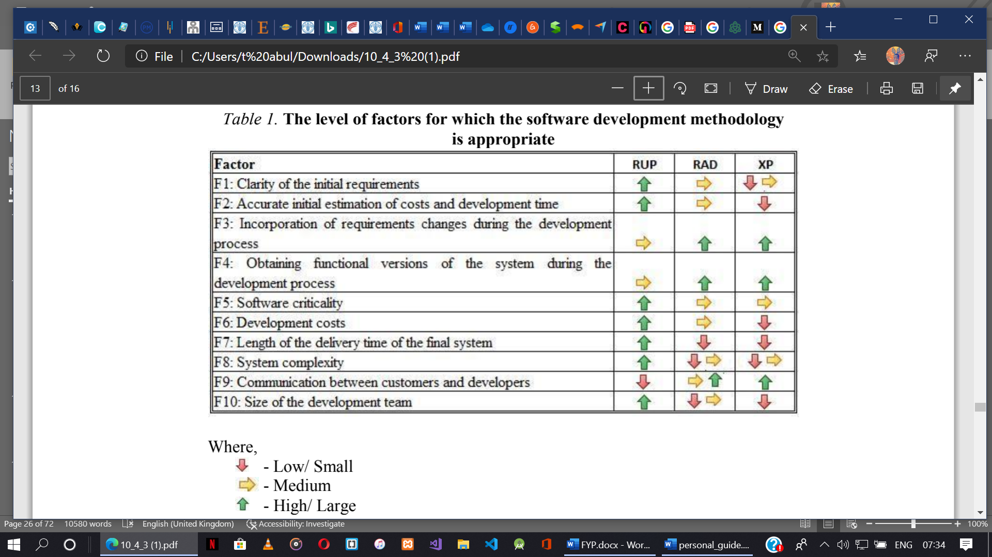

Figure ‎3.2 The level of Factors For Which Software Development Methodology is Appropriate (GAVRILĂ et al. 2011)

Figure 3.2 is an image of a table that was created by GAVRILĂ et al. depicting that, depending on the level of a factor, for a particular project, some methodologies may be appropriate while others could lead to a failure (2011).

With the proposed methodology, system implementation will be done incrementally with iterations and prototypes. As early as possible, requirement will be gathered and used to develop a prototype for user examination. The prototype, depending on the feedback received, will be modified, and the interactive process will continue until an acceptable system is developed.

## 3.3. Project Plan

Once the project is examined to be feasible, the planning of the project is done. The following table shows how the project was planned.

|  |  |  |  |
| --- | --- | --- | --- |
| **Phases** | **Time Period** | **No. Of**  **Days** | **Deliverables of The Phase** |
| Feasibility Analysis | 10th Feb – 17th Feb | 7 | Feasibility Report Document |
| Requirement Gathering | 17th Feb – 23th Mar | 35 | System Requirement Study |
|  |  |  |
| Analysis | 23th Mar – 24th Apr | 32 |  |
| Design | 24th Apr – 18th May | 24 | Design Document |
| Implement Coding | 18th May– 1st Jun | 14 | Implementation of System |
| Testing | 1st jun – 8th jun | 7 | Testing Document |
| Final Evaluation | On specified date | 1 | Report Submit |

Table ‎3.1 Project Plan

## 3.4. Requirement Planning Phase

### 3.4.1. Feasibility Studies

A feasibility study is a study conducted to simply assess the method and practicality of the proposed system. It helps answer the question: “should we proceed with the proposed project idea?”. (Hofstrand 2009). The success rate, possibility of failure, value and significance for the target users are all deciding factors that contribute to how to proceed with the project. Studies on viability can be broken down into three categories: Technical, Economic and Operational Feasibility.

#### 3.4.1.1 Technical Feasibility

A study is conducted on the technical resources available to poultry farmers and individuals to determine whether or not, the technical resources meet capacity and is capable of converting the ideas into the proposed technology (simplilearn 2020). This involves the evaluation of the hardware, software, and other technical requirements. The proposed technology is deemed best to run on devices supporting Android Operating System with a camera in the presence of candling unit; the best choice of candler design, software and hardware served as developmental platforms for the technology.

#### 3.4.1.2 Economic Feasibility

This assessment is done to know the cost or benefits of the project before financial resources were allocated (simplilearn 2020). Obviously, the cost of set-up for the proposed technology tallied against the benefits expected such that the benefits outweigh the cost. Hence, validating the economic feasibility of the project. Moreover, the current technology being used, despite its inefficiency and low patronage, bears more cost as compared to the proposed technology. Thus, the proposed system is free of the ambiguity of cost-benefit analysis and savings.

#### 3.4.1.3 Operational Feasibility

The key aim of operational feasibility is to analyse and determine how much acceptance the system will receive for the problem it is to solve. For that purpose, the focus is on the allowance of the technology to candle chicken eggs at a more fast and efficient way (as long as the prerequisites –an android platform and a candling unit, are met), and the timely processing of the stages of eggs to users being calculated in real-time clock.

## 3.5. Requirements Specifications and Tools

Software requirement specification (SRS) defines the vital behavior of a software or system from a user's point of view. According to the Software Testing Class’s website (2015), primarily, SRS is a comprehensive overview of a software system to be developed with both functional and non-functional requirements. Also, there are secondary specifications like hardware and software specifications which will be discussed in this section.

### 3.5.1. Functional Requirements

 Generally, functional requirements describe system behavior under specific conditions (Software Testing Class 2018). It specifies what the system must do. A system is well-constructed when its functional requirements have been met. For the proposed system, the functional requirements are as follows:

* Egg Illumination: The system should allow the use of a candling unit to make the content of an egg visible.
* Realtime Egg Scan: The system’s android app should be able to continuously scan eggs in real time. Thus, a live scan with the rear of a camera.
* Egg stage determination: The system must be able to make internal classification using the embedded models. Thus, TensorFlow Lite should help the system make mathematical computations to make useful classification.
* Egg stage Feedback Report: After when the system has been able to make a successful computation of the received egg frames, it should be able to immediately read feedback to the user in the readable, and understandable format. Thus, whether Early stage, Middle Stage or late stage.

### 3.5.2. Non-functional Requirements

Nonfunctional requirements describe how a system must behave. It establishes the constraints of its functionality. Nonfunctional requirements are also known as system’s quality attributes (Software Testing Class 2018). Below are typical nonfunctional requirements for the system:

* Usability: The system will be easy to learn and operate. Frequently used functions will be prioritised. To promote intuition for users, the system will have a familiar layout. The average time a user takes to accomplish the ultimate goal of the system is 4 seconds.
* Performance: In relation to the system’s performance, the system will be optimised for real-time responses to various user interactions. Lag impact will be minimized as much as possible.
* Reliability: Where there is no technical hardware failure, the system should be accessible from any point as long as a recommended android phone with camera accessibility is available.
* Scalability: The system can grow without having any negative influence on its performance. In terms of hardware and software scalability, the system has its own implications which doesn’t cost it very much with regards to overall performance.

### 3.5.3. Hardware and Software Requirements

In building the system, these tools played a significant role. Below are the minimum hardware and software specifications.

#### 3.5.3.1. Hardware Requirements

The Proposed System has two sects of hardware. Thus, Hardware used for the Android Application and Hardware used for the designing the Candling Unit.

##### 3.5.3.1.1. The Android Application Hardware Requirements

Below are the hardware requirements for the Android Application of the system.

* Intel(R) Core (TM) i3-3227U CPU @1.90GHz
* 4.00GB RAM
* 400GB HDD
* Windows 10 Pro
* Android device in developer mode with USB debugging enabled
* USB cable (to connect Android device to your computer)

##### 3.5.3.1.2. The Egg Candling Unit Hardware Requirements

These Hardware listed below were used to develop the Egg Candling Unit.

Tools:

* Screw driver
* Harmer
* Saw

Material:

* Wood
* Flexible Wire
* Screw
* Nail
* Switch
* Battery

#### 3.5.3.2. Software Requirements and Tools

* Integrated Development Environment (IDE): Android Studio
* Operating System: Android
* Programming Language: JAVA
* Markup language: XML
* Machine Learning (ML) Tool: Azure Custom vision

## 3.7 User Design Phase

With current business processes, and the need for the new system properly established, the blueprint for the proposed system is developed. Thus, the overall system architecture is determined through the System Design, also known as User design. The requirements defined in the requirement planning phase serves as the primary inputs for design activities therefore, user design can only take place after the requirements of the system have been accurately gathered.

The major deliverable from this phase is the system specification, which includes the physical process and data models, architecture design, hardware and software specification, interface design and many more.

### 3.7.1. System Architecture

The purpose of system architecture is to determine a comprehensive solution based on concepts, principles, and properties that relate logically and are consistent with each other, as defined by SEBoK (2020). This means that, conceptually, certain representational models give the flow of the system activity and try to, as much as possible, show how the system is supposed to work.

Basically, the architecture of the proposed system is based on a smartphone with the following features; android operating system and camera accessibility, a modelled candling unit, and the user. Based on these components, the architecture can be grouped into two affecting modules:

* The User Module: The user module in this context represents all activities that involves user interaction during system execution. Thus, it covers the interaction from where the user places an egg on the candling unit to illuminate it, to the case where the user receives a classification result of the status of the egg on the Mobile App.
* The Server Module: This module uses a set of trained images exported in TensorFlow Lite format and incorporated in an android app to classify images detected by the rear of the camera. The “How of it”, is discussed in the next section. Microsoft Azure Custom vision was used in the training. Figure 3.3 below represents the system architecture:

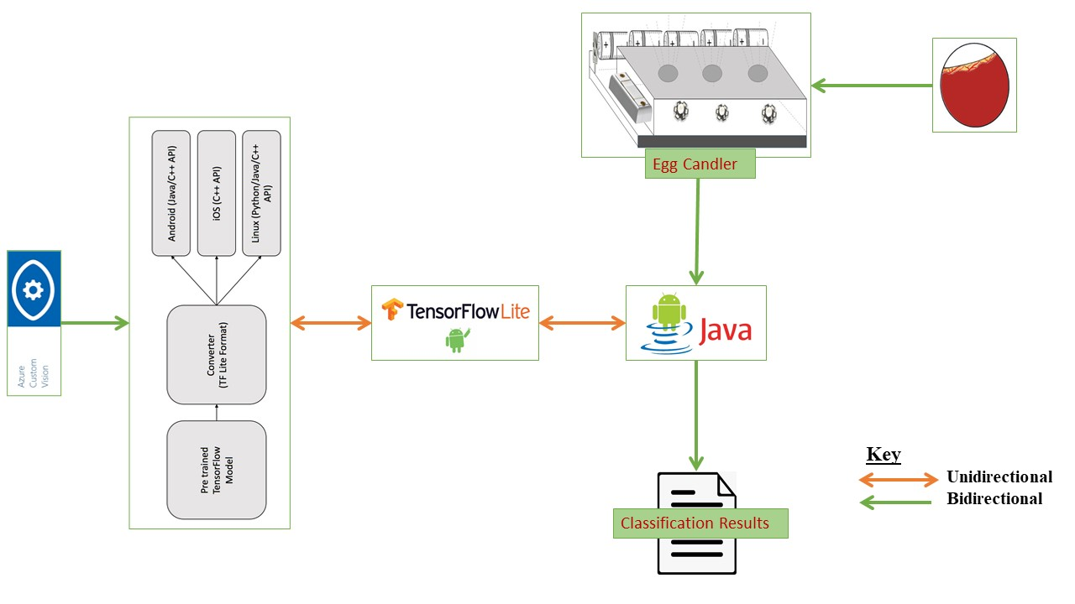

Figure ‎3.3 System Architecture (Author’s Design, 2020)

#### 3.7.1.1. Cognitive Services

Cognitive Services are a set of machine learning algorithms developed by Microsoft for solving Artificial Intelligence (AI) problems. The goal of Cognitive Services is to democratize AI by packaging it into discrete components that are easy for developers to use in their own apps. Cognitive Services APIs are grouped into five categories (Windows App Team n.d.). Namely:

Vision: analyse images and videos for content and other useful information.

Speech: tools to improve speech recognition and identify the speaker.

Language: understanding sentences and intent rather than just words.

Knowledge: tracks down research from scientific journals for you.

Search: applies machine learning to web searches.

##### 3.7.1.1.1 Azure Custom Vision Service

According to Microsoft (2020), Azure Custom Vision is a cognitive service that allows building, deploying, and improving of custom image classifiers. The image classifier is an AI service that applies labels (representing classes) to images according to their visual characteristics.

##### 3.7.1.1.2 How Azure Custom Vision Service Works

Azure Custom Vision service uses a machine learning (ML) algorithm to apply labels to images. Developers label and submit groups of images that feature and lack the characteristics in question. The ML algorithm is then used to train data and calculate accuracy by testing itself on those same images. Once the algorithm is trained, it’s possible to test, retrain, and eventually classify new images according to the App needs. The train models can also be exported for offline usage (Microsoft 2020).

##### 3.7.1.1.3 Azure Custom Vision Service Export Options

Azure Custom Vision Service is allowed to export classifiers and run them offline. It is possible to embed an exported classifier into an application and run it locally on a device for real-time classification. Exports supported by Custom Vision Service includes:

* TensorFlow - used for Android
* CoreML - used for iOS11
* ONNX - used for Windows ML
* Vision AI Developer Kit
* Docker container that includes a TensorFlow model and service code (custom vision API) used the in Windows, Linux, or ARM architecture.

#### 3.7.1.2 TensorFLow Model

A TensorFlow model is a data structure that contains the logic and knowledge of a machine learning network trained to solve a particular problem (TensorFlow 2020). Although it is possible to obtain a pre trained TensorFlow model, the model used in this project was custom trained. For this system, TensorFlow Lite model was employed.

TensorFlow Lite is an open source machine learning platform that allows the use TensorFlow on IoT and Mobile devices.

It worth knowing that, to use a TensorFlow Lite model, it must be first converted form a full TensorFlow model into a TensorFlow Lite format. Creating or training a model using TensorFlow Lite is not possible hence, we start with a regular TensorFlow model, and then convert to TensorFlow Lite format. For this project, Azure did the hard task of the conversion.

### 3.7.2 Modelling of the Egg Candler Unit

The Egg Candling unit is a hardware modelled as part of the smart egg candling system. Its main purpose is to illuminate eggs, making vision through the shells of the eggs possible. As part of its functions is being able to keep the eggs still, preventing it from cracks and embryo damage. The candling unit provides the means for the Android software to scan and analyse eggs, thus, providing clearer egg image for classification. Many parts form the egg candling unit including:

* Rubber Ring: The Rubber ring is used to trap the excess light that may escape from the bottom of the eggs. It also had the purpose of keeping the eggs from falling and prevent it with a crack.
* Reflector: The role of the reflector in the egg candling unit is to gather the light emitted by the source and focus it out thus creating a strong beam of light to illuminate the eggs.

Other components of the egg candling unit such as LED, Switch, Wire and 1.5v Battery are discussed in the circuit diagram section of the egg candling unit since they better fit there.

Figure 3.4 below, shows the various part of the Egg Candler Unit design;

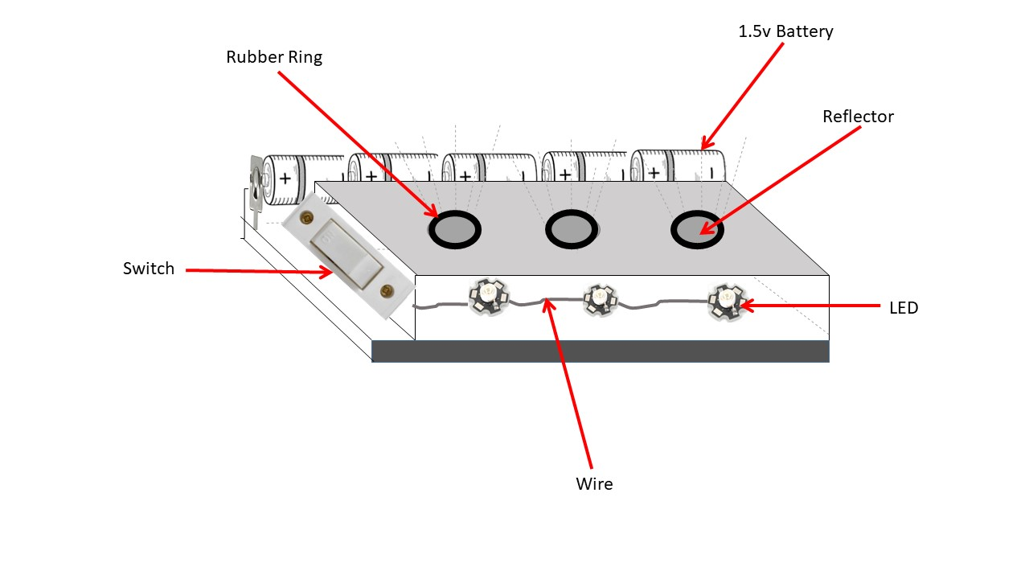

Figure ‎3.4 Egg Candler Unit Model (Author’s Design, 2020)

##### 3.7.2.1 Egg Candler Unit Circuit Diagram

According to Visual Paradigm (n.d), Circuit diagram is a graphical representation of the physical arrangement of all components in a circuit and the wire relationships between them. They stated that, a technician creates a circuit diagram as a guideline for implementing circuit design or for communication.

Below is Figure 3.5, the egg candling unit circuit diagram, created as a blueprint of the circuit design.

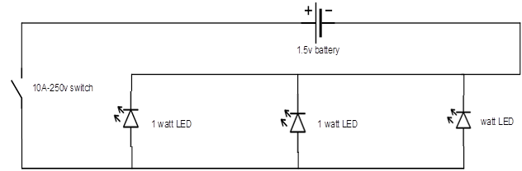

Figure ‎3.5 Egg Candler Unit Circuit Diagram (Author's Design, 2020)

The components forming the circuit diagram are as follows:

* Switch: The switch in the circuit had the purpose of making it easy to open or close the electrical circuit, turning the flow of current on or off.
* Battery: The battery served as a source of energy for the egg candling unit circuit.
* Wire: The wire served as a bus, connecting all other components together. It allowed the flow of current among the circuit components.
* LED: LED is an electronic device that emits light when an electrical current is passed through it.

### 3.7.3 Use Case Diagram

Use case diagrams are behaviour diagrams that model’s a system’s functionality, using actors and use cases. The actors are the beneficiaries of the system and correlates to use cases which are functionalities of the proposed system represented by oval figures below:

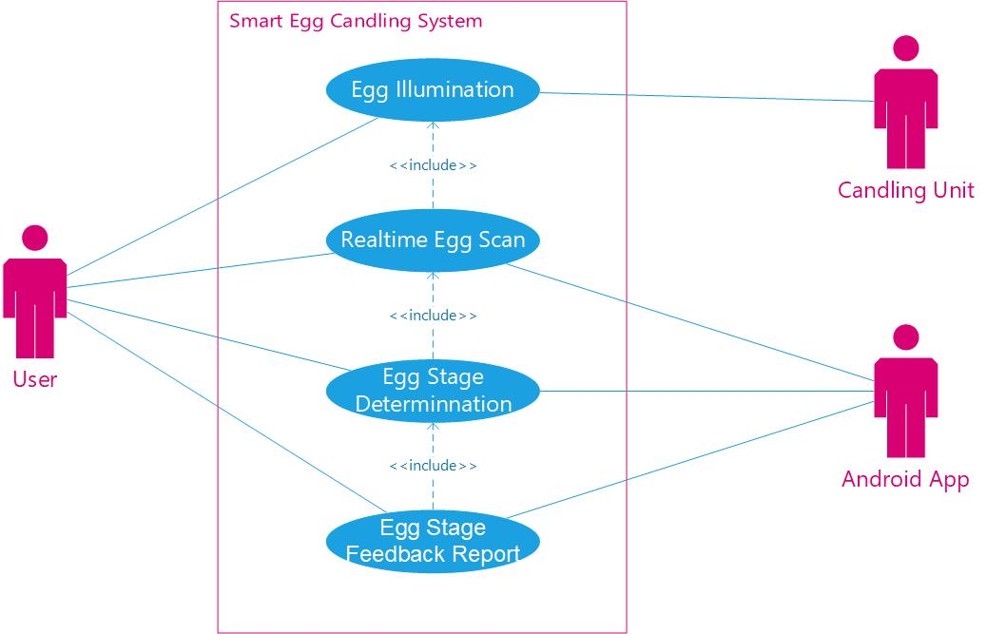

Figure ‎3.6 Use Case DIagram of the Smart Egg Candling System (Author’s Design, 2020)

### 3.7.4 Sequence Diagram

Sequence Diagrams are UML interaction diagrams that detail how operations are carried out. They are time focus and visually show the order of interaction. The vertical axis of a sequence diagram represents the time what messages are sent and when. Below are presentations of the system’s use cases using a sequence diagram.

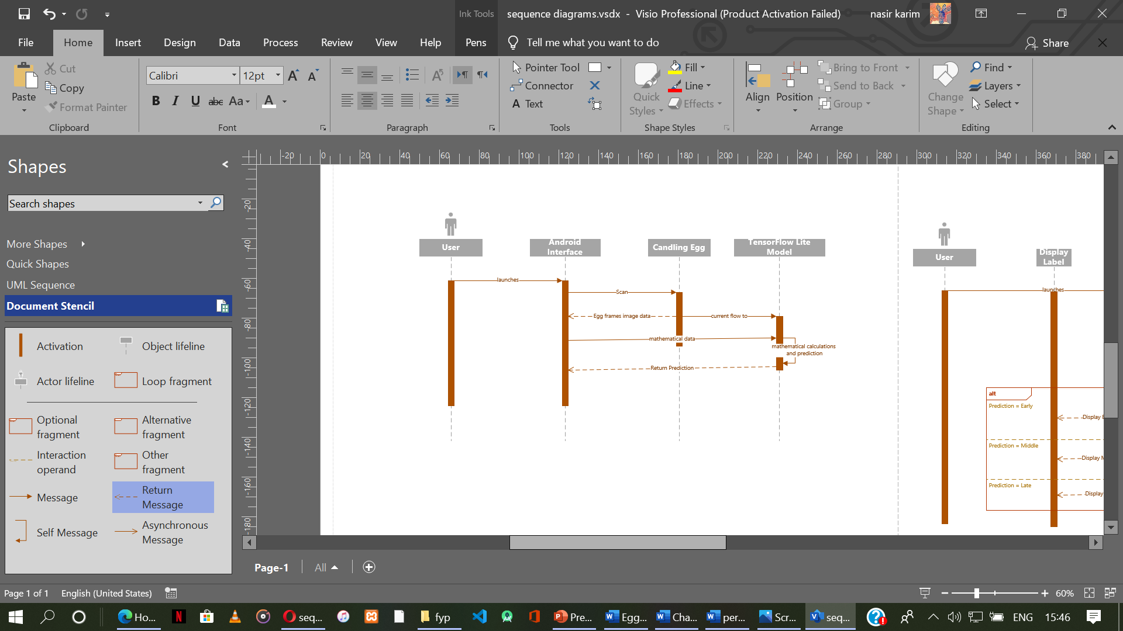

Figure ‎3.7 Egg stage prediction Sequence Diagram (Author's Design, 2020)

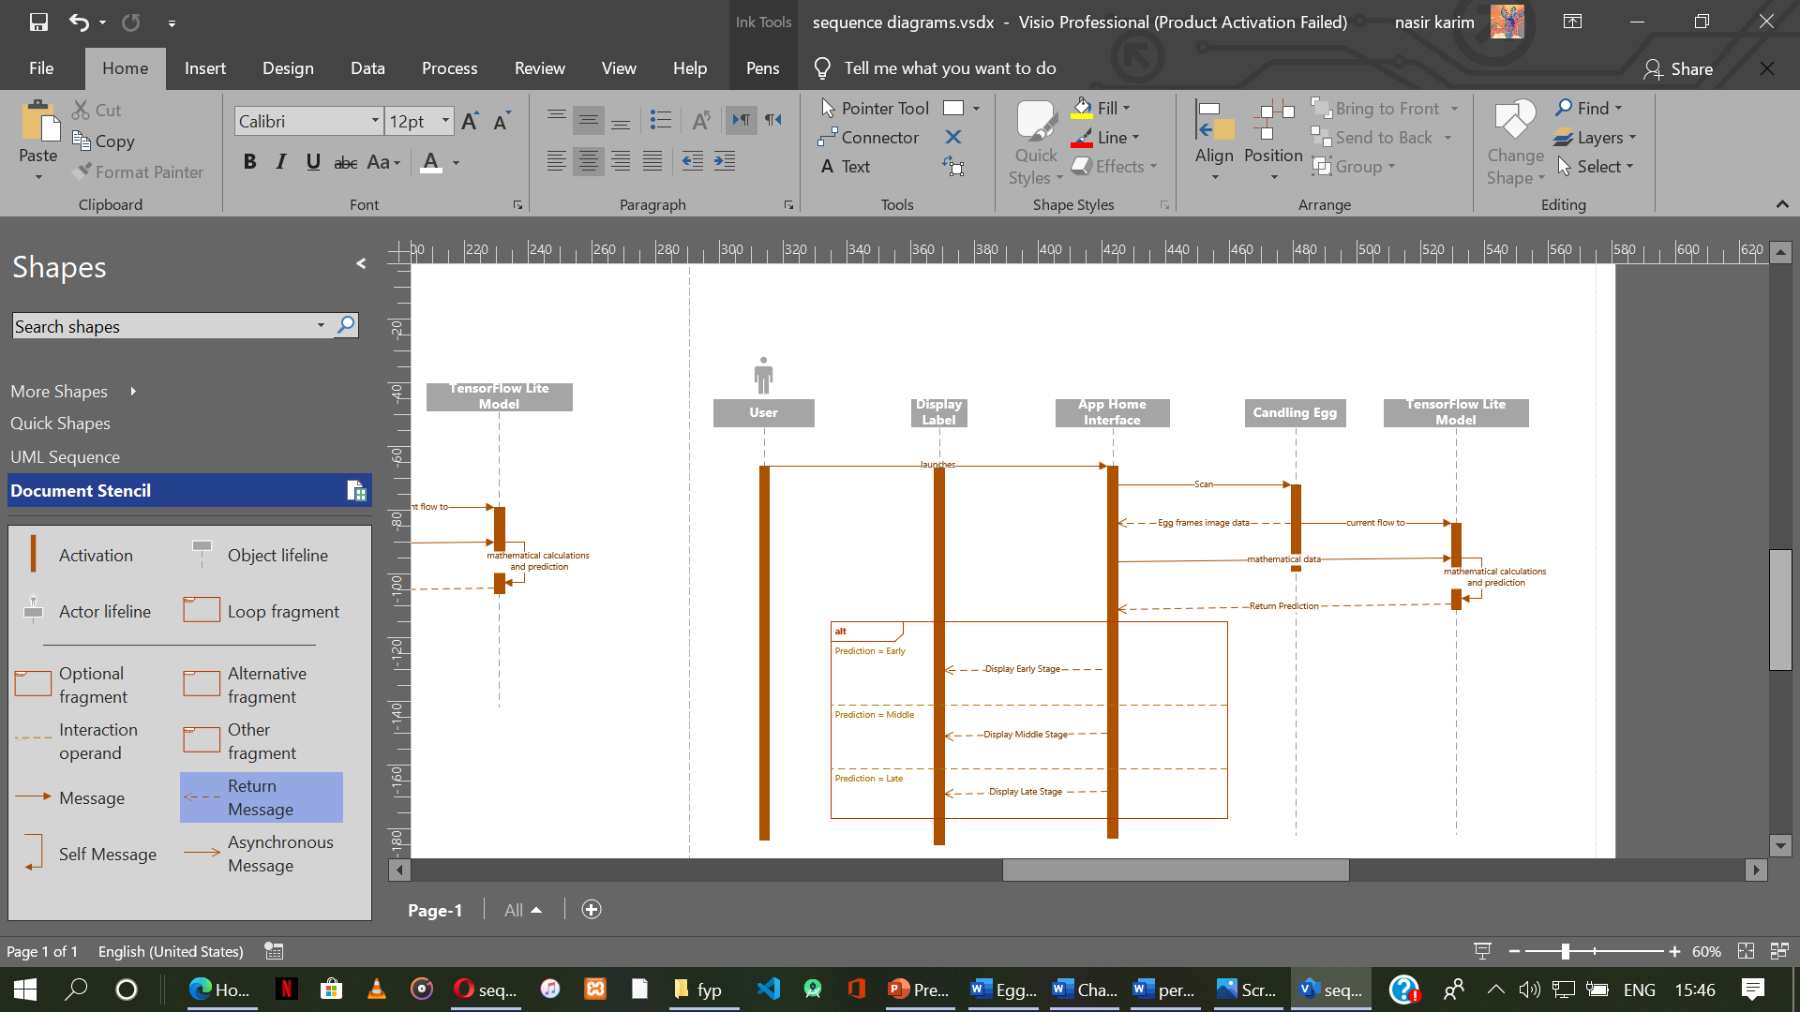

Figure ‎3.8 Sequence Diagram for Obtaining Egg Stage Results (Author’s Design, 2020)

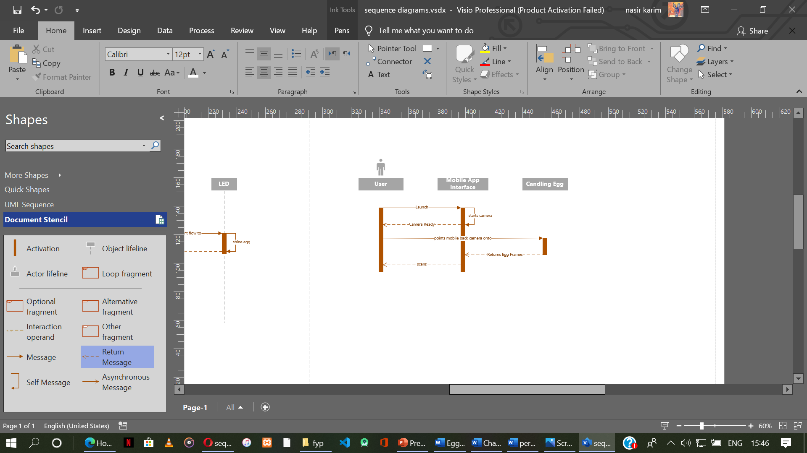

Figure ‎3.9 Sequence Diagram for Eggs Scan (Author's Design, 2020)

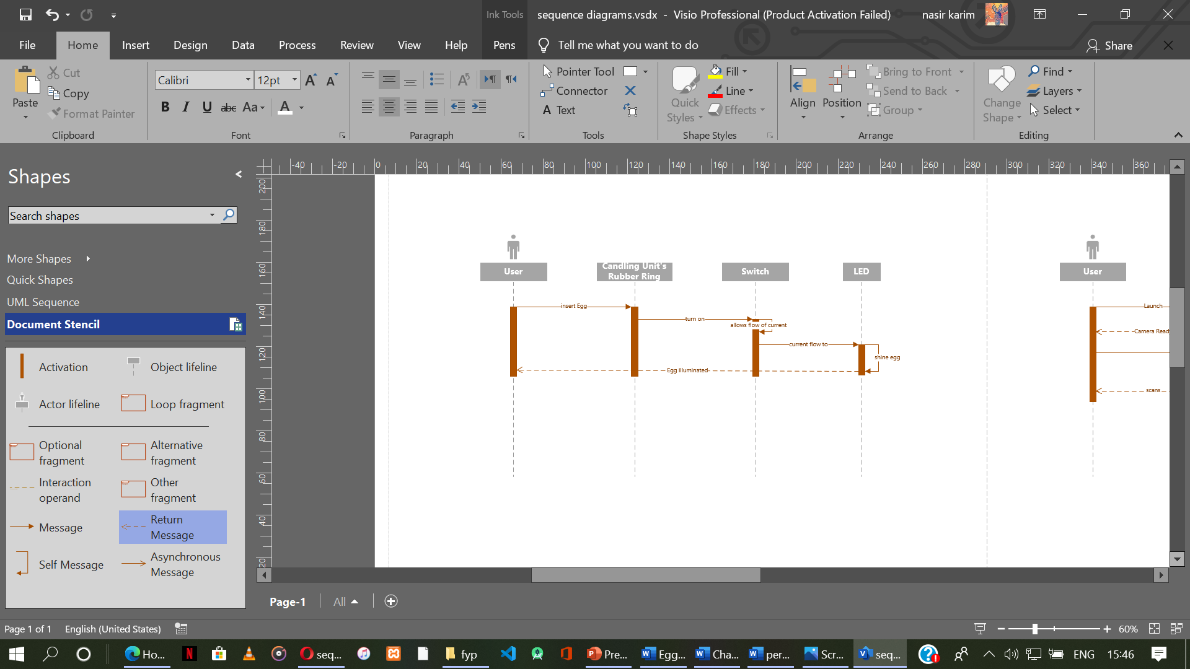

Figure ‎3.10 User Illumination of Eggs Sequence Diagram (Author’s Design, 2020)

### 3.7.5 Activity Diagram

Activity diagrams are used to illustrate the flow of controls in a system. Basically, to visually depict the workflows of a system and portray the control flow from a starting point to a finish point. Below are some activity diagrams for this system.

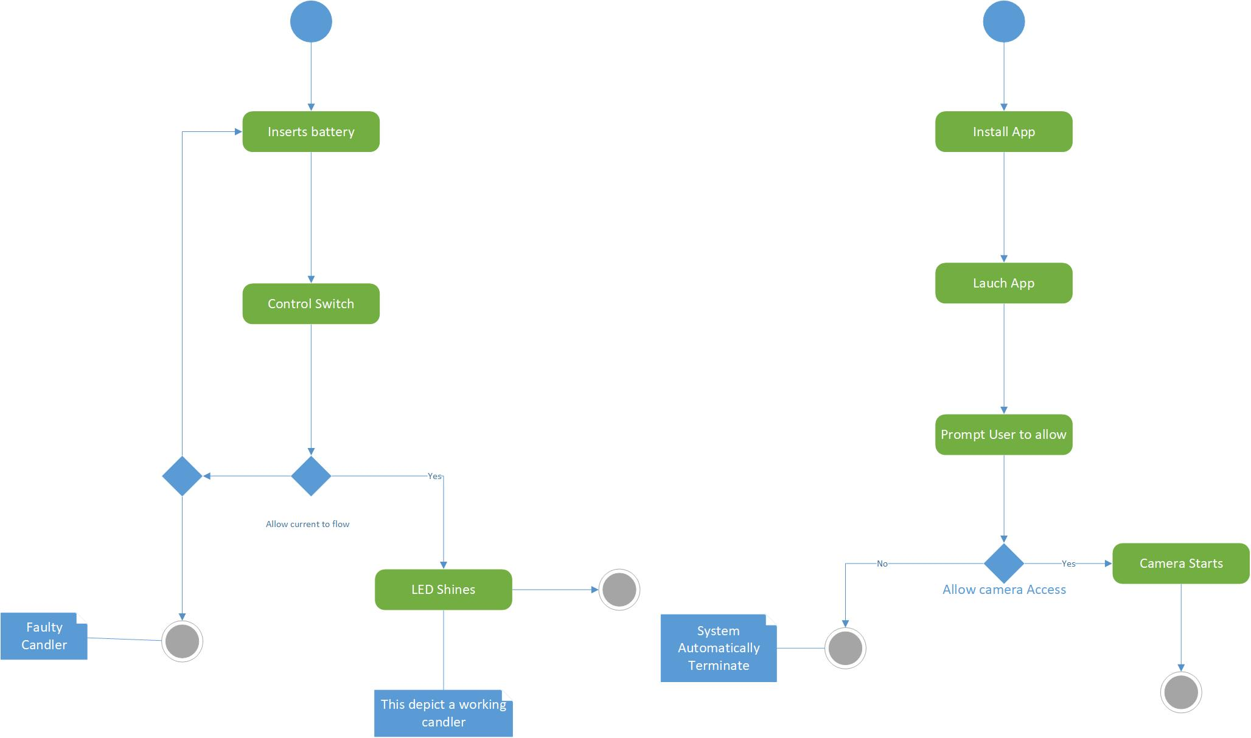

Figure ‎3.11 Egg Candling Unit Setup Activty Diagram (Author’s Design, 2020)



Figure ‎3.12 Mobile App First Time launch Activity Diagram (Author’s Design, 2020)

# Chapter Four: System Testing and Implementation

## 4.1. Introduction

This Chapter explicitly discusses the means employed to successfully arrive at the end-product of the study and also involves system testing to make sure the system functions as intended.

## 4.2 Construction Phase

The construction phase includes the refinement of the prototypes already developed. This is where powerful automated tools are used for transforming process and data models into the final, operational system. All the collected enhancements and modifications are applied. User feedbacks play an important role here.

This system is composed of two main sub-system. Thus, an Android software and an egg candling unit. The Egg candling unit serves as a medium to illuminate the eggs while the mobile software (Android), with the help of a camera, scan and analyse the eggs placed on the candling unit for classification. Internet is not a key requirement for this system.

## 4.3 Development Tools and Technologies

Many materials, tools and technologies were employed towards the completion of the Smart Egg Candling system. Below is a presentation of the most useful tools used for the development of the Egg Candling Unit and the Android App respectively.

### 4.3.1 Tools and Materials Used for The Egg Candling Unit

Towards the development of a working candling unit, some useful materials and tools employed are:

* PlyWood: Plywood is an engineered wood made from multiple layers of thin veneer that are glued together (Q&Q Club n.d). It is was used to join and provide a surface for the candling unit.
* Screw: A screw is a metal fastener having a tapered shank with a helical thread, and topped with a slotted head (Dictionary.com n.d). It was used to for tightening and joining some parts of the egg candling unit together.
* Screw Driver: A tool used for driving screws into a wood by rotating.
* Nail (Fastener): A nail is a small object made of metal. It was used as a fastener to join the 2x2 wood and other woods together.
* Hammer: A tool used for driving the nail into wood.
* Saw: It’s a tool used for cutting. The saw was used for cutting the plywood and other woods in to the desired size.
* Wire: A wire is a cable which carries power or signals from one place to another. It was used to join other electrical components in the Egg candling Unit.
* LED: The LED is a circuit component, used in the development of the egg candling circuit. It served as the light source for illumination of eggs.
* Switch: As a breaker, It was used to turn on and off the whole egg candling unit. Thus, allowing or disallowing the flow of current in the candling unit.
* Battery: The battery served as the source of power for the candling unit.

### 4.3.2 Development Tools and Technologies Used for The Android Software

During programming, tools employed include:

* Android Studio: It is the official Integrated Development Environment (IDE) for Android app development (Android Studio n.d.)
* XML: Extensible Mark-up Language (XML) is used for designing the layout of an Android app (AbhiAndroid n.d.)
* Java: A programming language that helps in “bringing to life” the interface features of the app and incorporating of the AI.
* Microsoft Azure Custom Vision AI: It allows building and training of model, dedicated to a given image domain (Zone 2018).
* TensorFlow Lite: it allows running of a machine-learned models on mobile devices with low latency, in order to do classification, regression or anything without necessarily incurring a round trip to a server.

## 4.4 Presentation of System

### 4.4.1 Egg Candling Unit

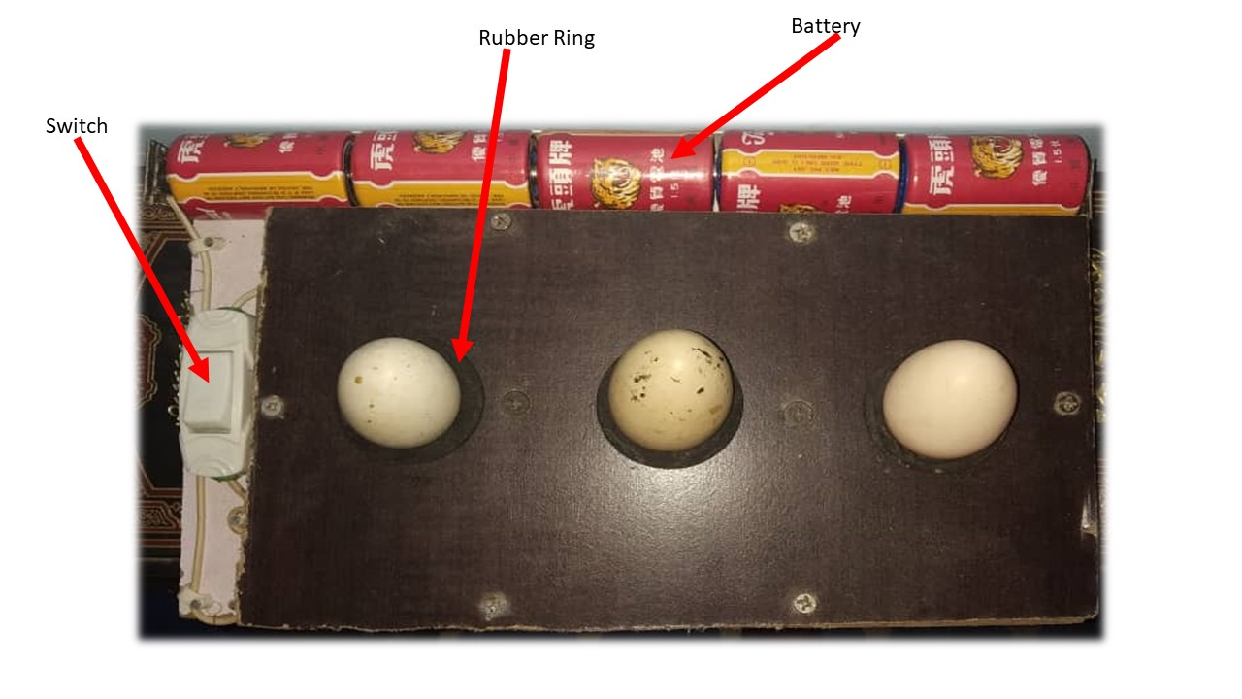

Figure ‎4.1 The Egg Candler Unit (Authors Design, 2020)

Figure 4.1 above is the egg candling unit that has the role of illuminating eggs for candling to be possible. For demonstration purposes, the egg candling unit is designed to allow three eggs to be placed on it, even though it can be easily twisted to allow more eggs to be seated on it at time. Thus, according to the user’s preference.

As discussed already, Within the rubber ring is a reflector that is used to direct the LED to the egg as much as possible to make a strong or better illumination. Below is figure 4.2 showing the reflector and the LED components of the egg candling unit.

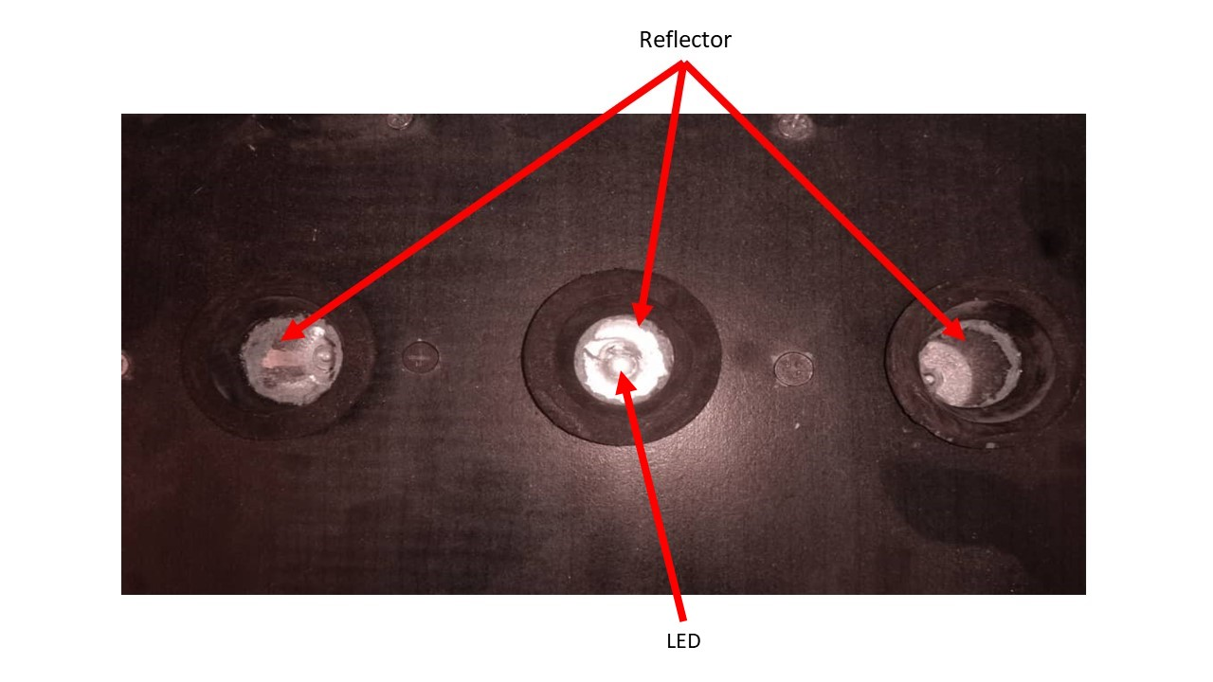

Figure ‎4.2 Reflector and LED of The Egg Candling Unit (Authors Design, 2020)

### 4.4.2 Android App System interface

* This is the page where a user is sent to upon opening the android application. Here, the user is able to scan eggs using the rear of the phone’s camera - by a continuous classification of frames (eggs) in real-time. Below is Figure 4.3, a screenshot of the app while scanning an egg.

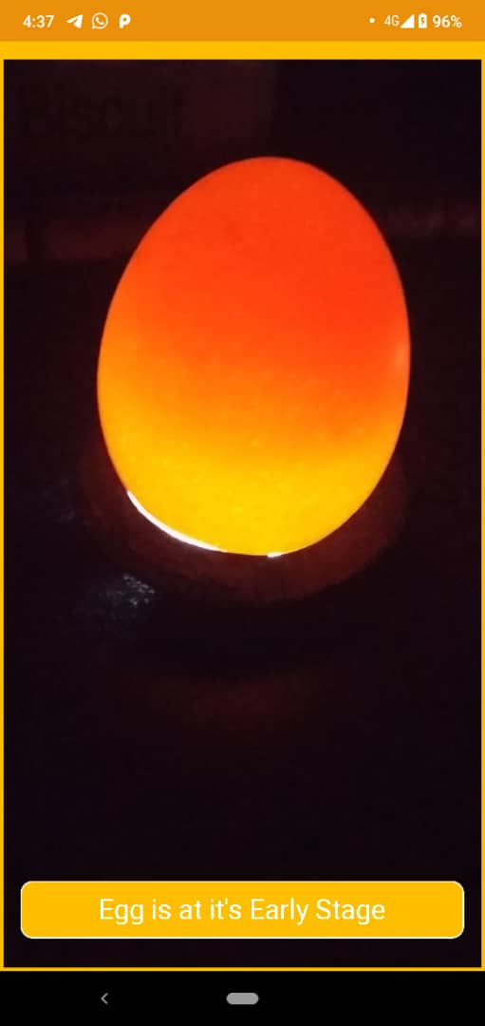

Figure ‎4.3 Graphical User Interface of the Android App (Author’s Design, 2020)

* Figure 4.4 below shows a label found on the Graphical User Interface of the android app. Its purpose is to display the different stages of the eggs as its been scanned and analysed. It takes a maximum of 4 seconds to change when moved or pointed to a different egg.

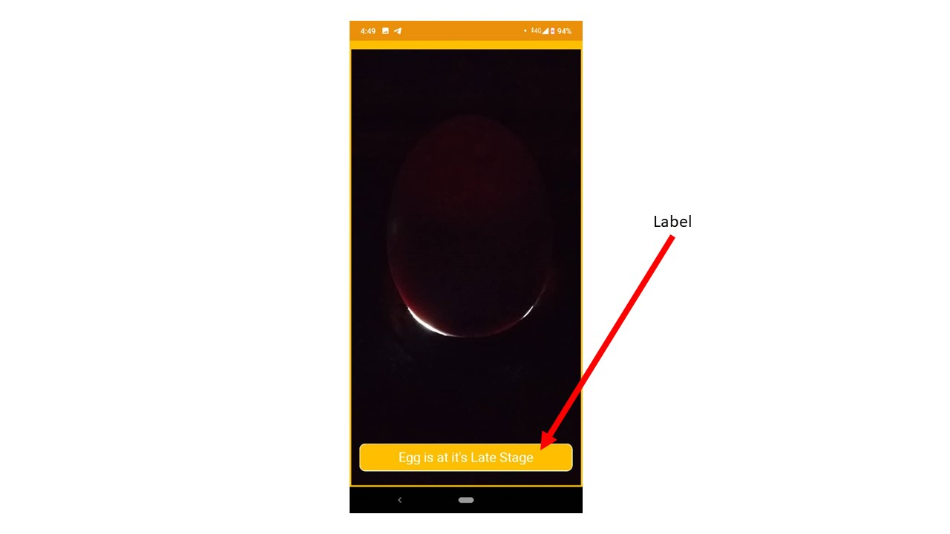

Figure ‎4.4 Graphical User Interface of the Android App (Author’s Design, 2020)

## 4.5 Testing

According to Strongqa, testing is the process of evaluating a system or its component(s) with the intention of deciding whether or not it meets specified requirements (n.d.). To make system perform well, it should be error free. Basically, testing identifies potential errors, gaps or missing requirements contradicting current requirements. There are many types of testing including unit testing, integration testing, and system testing.

### 4.5.1 Testing Process

Testing of the activities of the software process, including Design, Implementation and Requirement Engineering, is carried out. This is because system hardware and software layout errors are very difficult to restore as soon as the system starts to function. It is quite apparent to restore them at an early level of the system. Hence, Analysis is the most essential procedure in any project.

### 4.5.2 Requirement Traceability

The most critical aspect of the testing is to ensure that the system works as expected. To ensure that, multiple eggs were placed on the candling unit to illuminate, scan, and classify them into their various stages in order to spot where the system fails or experiences a break down. All problems were then resolved to ensure reliability, performance and effectiveness of the system.

### 4.5.3 Testing Schedule

Testing was carried out at the initial stage of the system to ensure that errors were detected and corrected as soon as possible. For the egg candling unit, chicken eggs were placed in the rubber ring of the candling unit to illuminate them.

Also, for the mobile development portion, the mobile application was tested on multiple versions of the Android operating system, none lower than the minimum SDK version mentioned above, to ensure optimum performance.

### 4.5.4 Testing Strategy

The approach used during the tests must ensure that all the quality and performance criteria are met.

### 4.5.5 Unit Testing

It is defined as a type of software testing where individual units or components of a software are tested as “iterations” are being worked on, purposely to validate unit or component of the software code performs as expected (Guru n.d.).

### 4.5.6 Integration Testing

Integration Testing, also performed by developers, involves testing between integrated components or systems, to expose defects in interfaces and interactions. software components, hardware components or both are combined and tested to evaluate the interaction between them (IEEE, 1990). Integration testing results in the assurance that the system is properly integrated with a smooth transition of data.

For this system, test case of both unit and integration testing is presented below. In this document, six test cases are reported in all for the android app and candling unit.

Below are two test case for the egg candling unit:

Test cases One (1):

Test Name: Illumination of eggs

Test Purpose: To check whether the light source of the egg candling unit can strongly illuminate chicken eggs of any kind and colour.

Test Input Data: Different colours of chicken eggs (brown and white)

Expected Result: The result expected from this test is; making chicken eggs placed on the candling unit transparent enough to allow vision through it shells.

Actual Result: The eggs placed on the candling unit allowed enough light through it. Below is Figure 4.5, showing this test results.

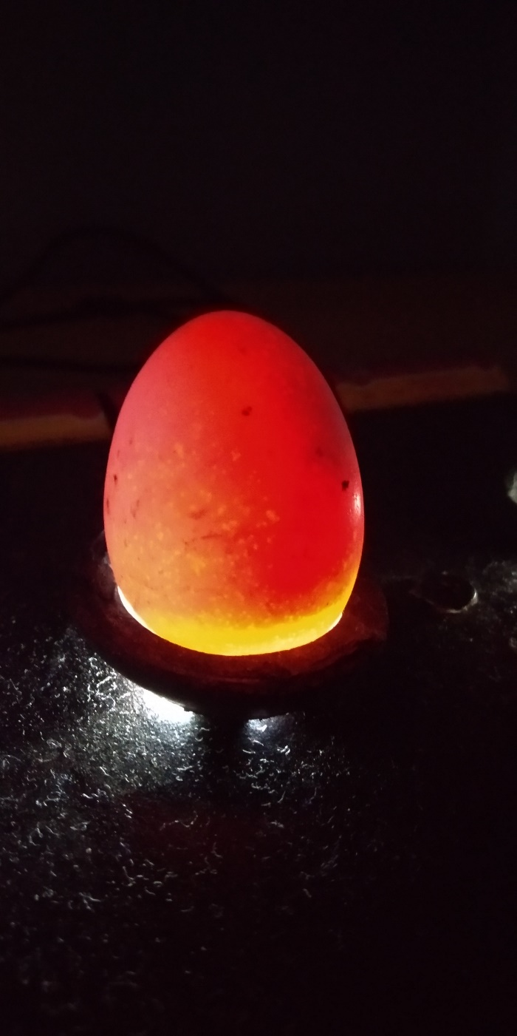

Figure ‎4.5 Chicken Egg On Rubber Ring (Author's Design, 2020)

Test cases Two (2):

Test Name: Egg Holding Testing

Test Purpose: To verify and ensure the designed candling unit is able to hold and keep the candling eggs firm. Thus, firm enough without causing cracks to the eggs.

Test Input Data: Different size of eggs

Expected Result: Eggs are expected to sit well on the candling unit without causing cracks.

Actual Result: Even though there were very small eggs that had issues sitting properly on the candling unit, most eggs were of similar size to the once used for the design of the egg candling unit, hence, many fit successfully. Figure 4.6 below is an indication of different sizes of eggs, sitting on a candling unit.

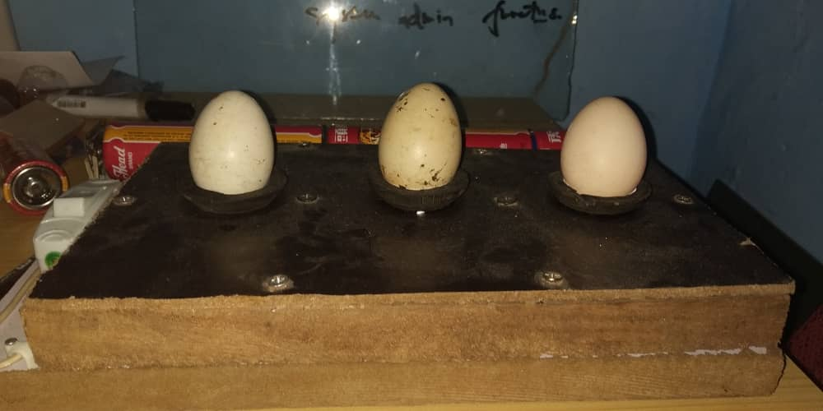

Figure ‎4.6 Egg Candling Image (Author’s Design, 2020)

Also, here comes the presentation of test cases, pertaining to the android software development of the smart egg candling system.

Test Case (3)

Test Name: Image Prediction

Test Purpose: To ensure the trained image have been successfully tagged to the right tags.

Test Input Data: Late stage egg Image

Expected Result: The Prediction of the egg should be - late stage.

Actual Result: The result obtained from this test was as expected. Thus, the prediction successfully predicted the egg to be of its late stage. Below is figure 4.7, showing the results of the prediction.

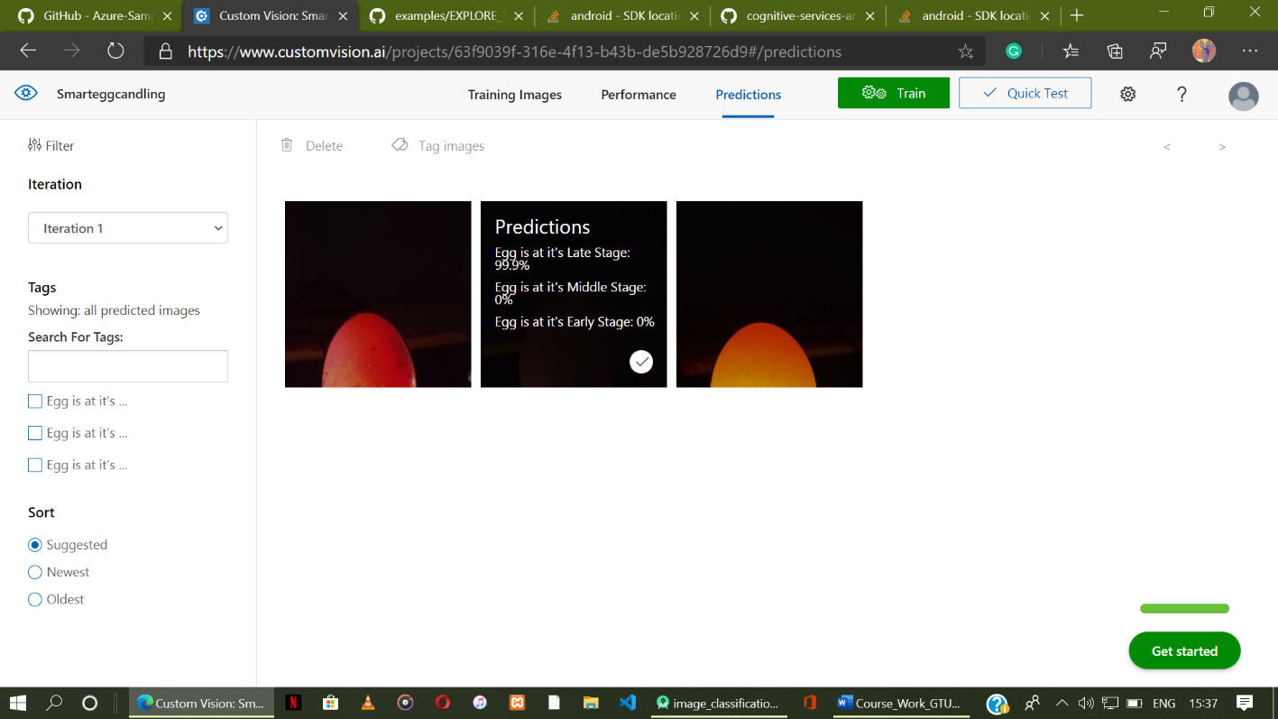

Figure ‎4.7 Screenshot of Azure Custom Vision Site (Author’s Design, 2020)

Test Case (4):

Test Name: App Lunch

Test Purpose: To ensure the app start or launch successfully without stoppage or system errors.

Test Input Data: a single tap on the app icon

Expected Result: The app should ask for permission to use camera and depending on the phone, ask for storage too.

Actual Result: The app successfully, was launched seeking for permission to use camera.

Test Case (5):

Test Name: Auto egg scan and analysis

Test Purpose: To test whether the android software can automatically scan and analyse eggs placed on the candling unit.

Test Input Data: live frames of eggs placed on candling unit

Expected Result: The android app should be able to successfully scan and analyse eggs.

Actual Result: The result was encouraging. The app scanned and analysed live frames of the eggs on the candling unit.

Next Test Case (6):

Test Name: Average time for egg classification

Test Purpose: This was tested to know whether the system meets the average time anticipated for classifying eggs.

Test Input Data: Live egg frame (images), placed on the candling unit

Expected Result: The average time expected for a single egg classification is four (4) seconds

Actual Result: The actual results obtained from this test, considering a stop watch with the android app already launched, and the egg candling unit set-up, was 3 seconds.

### 4.5.7 User Acceptance Testing

User acceptance is a critical factor for any system’s success as it is the final stage of a testing process before a system is accepted for operational use. The system is tested, not with simulated test data but rather, with data provided by the system customer. Due to the fact that real data sets are used for the testing, acceptance testing may expose system requirement specification errors and omissions. (Sommerville, 2009).

### 4.5.8 Usability Testing

A usability test is conducted to ensure the interface of an Application under development (AUT) is developed in a way that fits the user’s requirements (effectiveness) easily (efficiently) in a simplistic satisfying manner (Software Testing Help 2020).

Usability primarily focuses is on the ease of use of the system, ease of learning or familiarizing with the system and the satisfaction of the user with the entire experience (Software Testing Help 2020).

Usability has many dimensions to it. It is all about the user’s ‘experience’ during their interaction with an application (system) and their ‘feeling’ towards it. A structured Usability Test translates this experience/feeling into a Validation Process (Software Testing Help 2020).

#### 4.5.8.1 System Usability Scale

For the usability test of this system, system usability scale (SUS) was employed. According to John Brooke (1986), it allows evaluation of a wide variety of product and software including hardware, software mobile devices, websites and applications.

Respondents (System Users) had the opportunity to use the smart egg candling system before any debriefing or discussion took place. They were instructed to record their immediate response to a 12-item questionnaire with five response options; from Strongly agree to Strongly disagree on the usabliTest website. Figure B in the appendix shows a sample of the 12-item questionnaire used.

Below is Figure 4.8, showing the result of the John Brooke (1986) “quick and dirty” scale for administering usability tests.

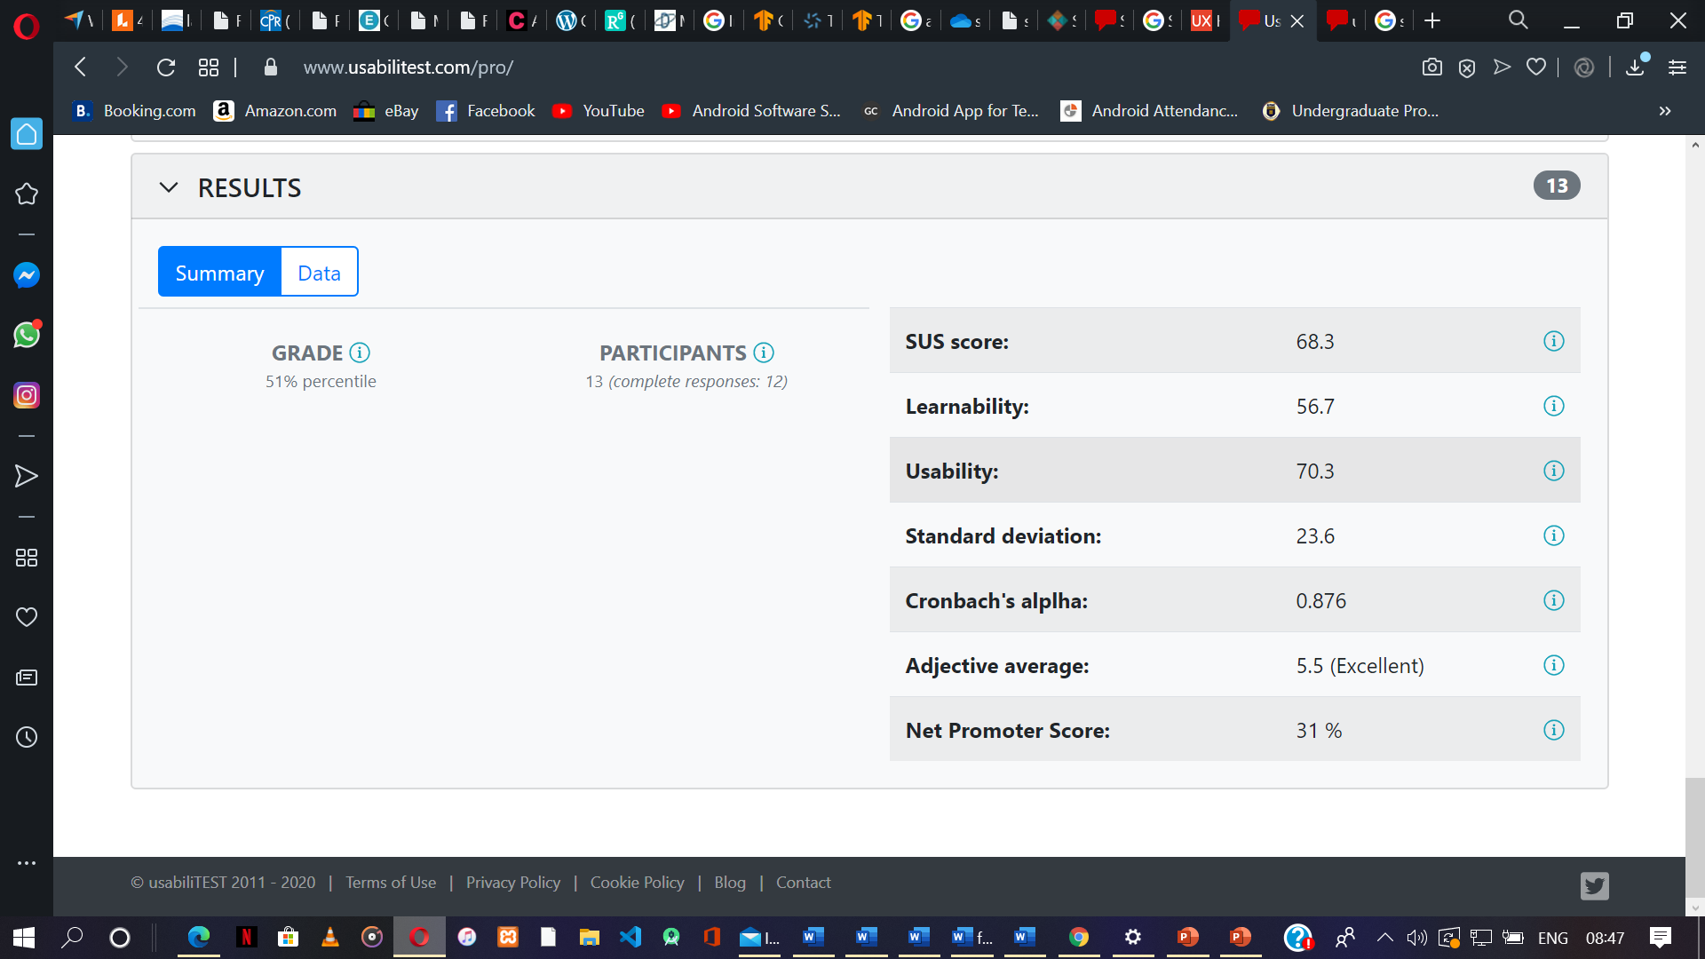

Figure ‎4.8 SUS usability Test Results Summary for the Smart Egg Candling System (Author’s Design, 2020)

For a better understanding of the Above test result, here are some useful definitions to help.

* SUS Score: This score represents how usable and learnable the system is. Note that 68 is the Average SUS Score. That means that, if SUS score is above 68, the score is above average. On the flip side, if the score is under 68, it is below average. A score of 75 is better than about 73% of SUS scores. Meanwhile, a score of 52 is worse than around 85% of scores.
* Learnability: This score represents whether a user would need a technical person’s support to be capable of using the system. The score also represents whether a user would need to learn a large amount of information before starting to use the system.
* Usability Score: This score refers to how easy it is for a user to make use of the system. How efficient can users use this system to accomplish their objectives both effectively and satisfactorily
* Standard deviation: This shows how much variation there is in the scores from the average SUS score. If the standard deviation figure is low, this means that the data are close to the average. Meanwhile, if the standard deviation is high, this means that the values are instead spread out over a much wider range.
* Cronbach’s alpha: In statistics, a Cronbach’s alpha is the measure of internal consistency. A reliability coefficient of .70 or higher is considered ‘acceptable in most social science research situations.
* Adjective Average: This part of the data results provides you with a word rather than a number to describe the user experience. Any score above 85 is ‘Excellent’. Where ‘Good’ is slightly above average.

# Chapter Five: Conclusion and Critical Evaluation

## 5.1. Introduction

In this concluding chapter, critical evaluation of the system is established to pinpoint shortcomings, possible alternatives and useful recommendations for future development plans.

## 5.2. Project Outcome

With regard to the system specifications, the developed system is functional. Users are able to Candle and analyse eggs as fast as 3-4 seconds even in a no-internet situation. The design of the Egg Candling Unit is supportive for candling and analysing of multiple eggs in the shortest possible time. The system allows minimum user interaction, making usability easy. Usage of the system’s application is satisfactory as there are no distracting texts or objects.

Though the system is easy and simple to use, from excerpts received from user assessment, more work can be done on the interface to make it more appealing.

## 5.3. Lessons Learnt

The Development of this project has exposed me to new experiences and diverse ways of doing things. A notable lesson is what very goes into research methodologies and analysis gathering. My supervisor, who guided and corrected my misconceptions of having done questionnaires that were not in line with due processes, have made me become more conscious of what kind of information gathering techniques is to be employed for appropriate tasks.

Professionally, I wasn’t able to handle this project as I should have due to improper project management techniques and scheduling of tasks to be completed, which caused me to be found pressed against time. Working in times of the Covid-19 pandemic is also a lesson that can’t be ignored as more of the work is be done remotely. All the same, I am grateful for what I have learnt through this journey.

## 5.4. Limitation of the System

In terms of the image classification, there are exceptions. For example, pointing the device’s back camera to any other spherical object with a background of a significantly different hue mistakes the object for an egg and produces funny results. Also, in cases where there are no to little light source to bulb the eggs, the system may not be able to make accurate or correct classification.

The system does not accurately classify eggs in a place where there is too much of light. For example, using the system under the direct sunlight or under the brightness of any light sources may hinder accuracy.

## 5.5. Recommendations

The system can be enhanced in myriad ways. Much improvement may, for example, be made in the system to correct the recognition and classification of objects other than eggs. In the current system, there may be the possibility of recognising and classifying tennis balls and other round objects as eggs which can be addressed as a result of this improvement.

The system can be expanded to classify other eggs. For instance, eggs such as Duck’s eggs and many more, can be as well, trained and incorporated into the system for more classification.

Also, more improvement can be added to check eggs brought on the borders of Ghana. Thus, ensuring good and healthy consumption of eggs, and determination of egg price. A record section can be added to keep truck of eggs.

Talking about the United Nation’s SDG goals, I recommend many countries, especially Ghana, to invest in this project and many of it kind, since it can be a tool in helping to attain some of the 17 SDG goals including zero hunger, good health and well-being, decent jobs and economic development, poverty reduction and many more.

Finally, more resources can be invested in the line of this project to build a more standardized and efficient system that can go a long way to help improve the lives of poultry farmers.

# Reference

Ministry of Food and Agriculture (n.d.) *Revamping The Poultry Sector In Ghana* [online] available from <https://mofa.gov.gh/site/publications/research-reports/54-revamping-the-poultry-sector-in-ghana> [12 February 2020]

Aning, K.G. (2006) ‘FAO Animal Production and Health Division’. *Poultry Sector country reviews* 1(1), 13-14. available from <http://www.fao.org/tempref/docrep/fao/011/ai354e/ai354e00.pdf> [12 February 2020]

Anthony, N.A. (2013) ‘FAO Animal Production and Health’. *Livestock country reviews* 6(6), 20-21. available from <http://www.fao.org/3/a-i3663e.pdf> [12 February 2020]

Pulse Ghana (2018) *Research shows every Ghanaian ate 143 eggs in 2017* [online] available from <https://www.pulse.com.gh/news/business/egg-consumption-in-ghana-research-shows-every-ghanaian-ate-143-eggs-in-2017/jgw39bt> [12 February 2020]

The Poultry Guide (2013) *Over View of Different Stages of Egg Development* [online] available from <https://thepoultryguide.com/egg-development-stages/> [ 12 February 2020]

QC Supply (2018) *How-To Candle Eggs and Why It Is Important* [online] available from <https://www.qcsupply.com/blog/product-tips-and-how-tos/how-to-candle-egg-and-why-it-is-important.html> [12 February 2020]

Poultry Keeper (2018) *Candling Eggs* [online] available from <https://poultrykeeper.com/incubating-and-hatching-eggs/candling-eggs/> [12 February 2020]

Biomin (2019) *An Alternative Way to Boost Egg Production in Layers* [oniline] available from <https://www.biomin.net/science-hub/an-alternative-way-to-boost-egg-production-in-layers/> [14 February 2020]

Feed Greatness (n.d.) *Hatching Eggs at Home: A 21-Day Guide for Baby Chicks* [onine] available from <https://www.purinamills.com/chicken-feed/education/detail/hatching-eggs-at-home-a-21-day-guide-for-baby-chicks> [15 February 2020]

Raising Happy Chicken (n.d.) *Candling eggs: the fascination of watching a speck grow into a chick* [online] available from <https://www.raising-happy-chickens.com/candling-eggs.html> [16 February 2020]

Eugene, R. W. (2018) *Hachy* [online] available from <https://www.youtube.com/watch?v=y0aG22pkg6I> [21 February 2020]

SUNHAVEN (2018) *Importance of Poultry Food* [online] available from <http://sunhavenfarmsgh.com/index.php/blog-2-columns/88-importance-of-poultry-food> [22 February 2020]

HIPRA (n.d.) 1. The origins of poultry farming [online] available from <https://www.hipra.com/portal/en/hipra/knowledge/bgdetail/poultry-industry-curiosities/poultry-historical-origins> [22 February 2020]

Brinsea (n.d) INCUBATION TOPICS – What is egg candling and why you should [online] available from <https://www.brinsea.com/brochures/EggCandling.pdf> [23 February 2020]

Encyclopædia Britannica (2020) Food processing [online] available from <https://www.britannica.com/technology/food-processing> [23 February 2020]

Maddy, B (2016) Before selling eggs from a backyard flock, you must first know how to candle them [online] available from <https://newswire.caes.uga.edu/story.html?storyid=5851&story=Egg-Candling> [23 February 2020]

Cocks Machine (n.d.) The history of candling [Online] Available from <https://www.cocksmachine.com/en/fertility_test.html> [23 February 2020]

Delany, M., Tell, L., Millam, J., & Preisler, D. (1999). ‘Photographic Candling Analysis of the Embryonic Development of Orange-Winged Amazon Parrots (Amazona amazonica)’. Journal of Avian Medicine and Surgery [online] 13(2), 116-123. Available from <www.jstor.org/stable/30135215> [9 May 2020]

Chicken Scratch (n.d.) 7 Easy Steps to Candling Chicken Eggs [Online] Available from <https://cs-tf.com/candling-chicken-eggs/> [9 may 2020]

Hashemzadeh, M., Farajzadeh, N. (2016). ‘A Machine Vision System for Detecting Fertile Eggs in the Incubation Industry’. International Journal of Computational Intelligence Systems, 850-862.

Incubator warehouse (n.d.) Egg Candlers [Online] Available from <https://incubatorwarehouse.com/egg-incubator-accessories/egg-candlers.html> [9 may 2020]

Best Automatic Chicken Door (n.d.) Best Egg Candler for Testing Eggs – Reviews of 2019 [Online] Available from <https://bestautomaticchickendoor.com/best-egg-candler/> [9 may 2020]

V. Patel, R. McClendon, and J. Goodrum(1998). ‘Color com-puter vision and artiﬁcial neural networks for the de-tection of defects in poultry eggs’. Artiﬁcial Intelli-gence for Biology and Agriculture, 163-176.

K. C. Lawrence, S. C. Yoon, G. W. Heitschmidt, D. R.Jones, and B. Park (2008). ‘Imaging system with modiﬁed-pressure chamber for crack detection in shell eggs’. Sensing and Instrumentation for Food Quality and Safety (2),116-122.

M. Juhola, & T. Grönfors (2015). ‘Variable Importance Evaluation for Machine Learning Tasks’. Encyclopedia of Information Science and Technology [online] (3), 306-313. Available from < http://doi:10.4018/978-1-4666-5888-2.ch029> [10 May 2020]

C. Vargas, S. Ramiro, S. Ruiz, C. Lourdes, L. Navas, C. María (2018). ‘Egg Candling Analysis Equipment Design: A Safety Solution’. Procedia – Social and Behavioral Sciences [online] (238), 501-506. Available from < <https://doi.org/10.1016/j.sbspro.2018.04.029>>

Poultry Poultry (n.d.). ECAT LASER LIFE CANDLING - EGGS CANDLING [Online] Available from <http://poultry.proultry.com/products/ecat/ecat-laser-life-candling-eggs-candling> [12 May 2020]

Techgeekbuzz (2019) *What is Rapid Application Development and When Should You Use It?* [online] available from <<http://www.techgeekbuzz.com/rapid-application-development-rad/>> [10 june 2020]

IOWA STATE UNIVERSITY (2009) *What is a Feasibility Study?* [online] available from <https://www.extension.iastate.edu/agdm/wholefarm/html/c5-65.html> [10 june 2020]

Exastax (2017) *TOP FIVE USE CASES OF TENSORFLOW DEEP LEARNING* [online] available from <<https://www.exastax.com/deep-learning/top-five-use-cases-of-tensorflow/>>

Visual-paradigm (n.d.) *How to Create Circuit Diagram?* [online] available from <<https://www.visual-paradigm.com/tutorials/how-to-create-circuit-diagram/>>

B&Q Club (n.d) *Plywood* [online] available from <<https://www.diy.com/departments/building-supplies/timber-sheet-materials/sheet-materials/plywood/DIY1291867.cat>>

Software Testing Help (2020) *Usability Testing Tutorial: A Complete Getting Started Guide* [online] available from <<https://www.softwaretestinghelp.com/usability-testing-guide/>>

simplilearn (2020) *What is Feasibility Study and Its Importance in Project Management* [online] available from <<https://www.simplilearn.com/feasibility-study-article>/> [1st march 2020]

Mymanagementguide (n.d*.) PROJECT MANAGEMENT METHODOLOGY: DEFINITION, TYPES, EXAMPLES* [online] available from <<https://mymanagementguide.com/basics/project-methodology-definition/>/> [1 march 2020]

UKEssays (2018) *Definition Of Fact Finding Techniques Information Technology Essay* [online] Available from <https://www.ukessays.com/essays/information-technology/definition-of-fact-finding-techniques-information-technology-essay.php?vref=1> [1 March 2020]

PC dreams (2017) *Requirement Analysis – Fact Finding Techniques*. 21 January. available from <<https://pcdreams.com.sg/requirement-analysis-fact-finding-techniques/>> [7 March 2020]

intellectsoft (2019) *What Is System Development Life Cycle* [Guide] available from <<https://www.intellectsoft.net/blog/what-is-system-development-life-cycle/>> [7 March 2020]

TechTarget (2019) *systems development life cycle (SDLC)* available from <<https://searchsoftwarequality.techtarget.com/definition/systems-development-life-cycle>> [12 March 2020]

Federal Financial Institutions Examination Council (n.d.) *Systems Development Life Cycle – Maintenance Phase* [online] available from <<https://ithandbook.ffiec.gov/it-booklets/development-and-acquisition/development-procedures/systems-development-life-cycle/maintenance-phase.aspx>> [12 March 2020]

Svitla (2019) *SDLC Methodologies* [online] available from <<https://svitla.com/blog/sdlc-methodologies>> [12 March 2020]

Tutorialspoint (n.d.) *SDLC - Waterfall Model* [online] available from <<https://www.tutorialspoint.com/sdlc/sdlc_waterfall_model.htm>> [17 March 2020]

Cprime (n.d.) *WHAT IS AGILE?* [online] available from <<https://www.cprime.com/resources/what-is-agile-what-is-scrum/>> [17 March 2020]

Capterra (2019) *What Is Rapid Application Development (RAD)?* [online] available from <<https://blog.capterra.com/what-is-rapid-application-development/>> [17 March 2020]

Newgenapps (2017) *What is Rapid Application Development? 5 Reasons for Using RAD* [online] available from <<https://www.newgenapps.com/blog/what-is-rapid-application-development-advantages-and-usage>> [17 March 2020]

Software Testing Class (2015) *Software Requirement Specification (SRS)* [online] available from <<https://www.softwaretestingclass.com/software-requirement-specification-srs/>> [20 March 2020]

Software Testing Class (2018) *Functional and Nonfunctional Requirements: Specification and Types* [online] available from <<https://www.softwaretestingclass.com/software-requirement-specification-srs/><https://www.altexsoft.com/blog/business/functional-and-non-functional-requirements-specification-and-types/>> [20 March 2020]

SEBoK (2020) *System Architecture* [online] available from <<https://www.sebokwiki.org/wiki/System_Architecture>> [20 March 2020]

Tensorflow Blog (2018) *Using TensorFlow Lite on Android* [online] available from <<https://blog.tensorflow.org/2018/03/using-tensorflow-lite-on-android.html>> [20 March 2020]

Android Studio (n.d.) *Meet Android Studio* [online] available from <<https://developer.android.com/studio/intro>> [20 March 2020]

Medium (2018) *Image recognition using the Azure Custom Vision Service* [online] available from <<https://medium.com/@ThisisZone/image-recognition-using-the-azure-custom-vision-service-c0bfc74a3343>> [20 March 2020]

Strongqa (n.d.) *Software Testing* [online] available from <<https://strongqa.com/qa-portal/knowledge-base/key-concepts/software-testing>> [20 March 2020]

Guru (n.d.) *Unit Testing Tutorial: What is, Types, Tools, EXAMPLE* [online] available from <<https://www.guru99.com/unit-testing-guide.html>> [20 March 2020]

UsabilityTest (n.d) *World-class online tools for Usability Testing & Information Architecture* [online] available from <https://www.usabilitest.com> [20 March 2020]

# Appendixes

**Appendix A**

A sample project logbook filled

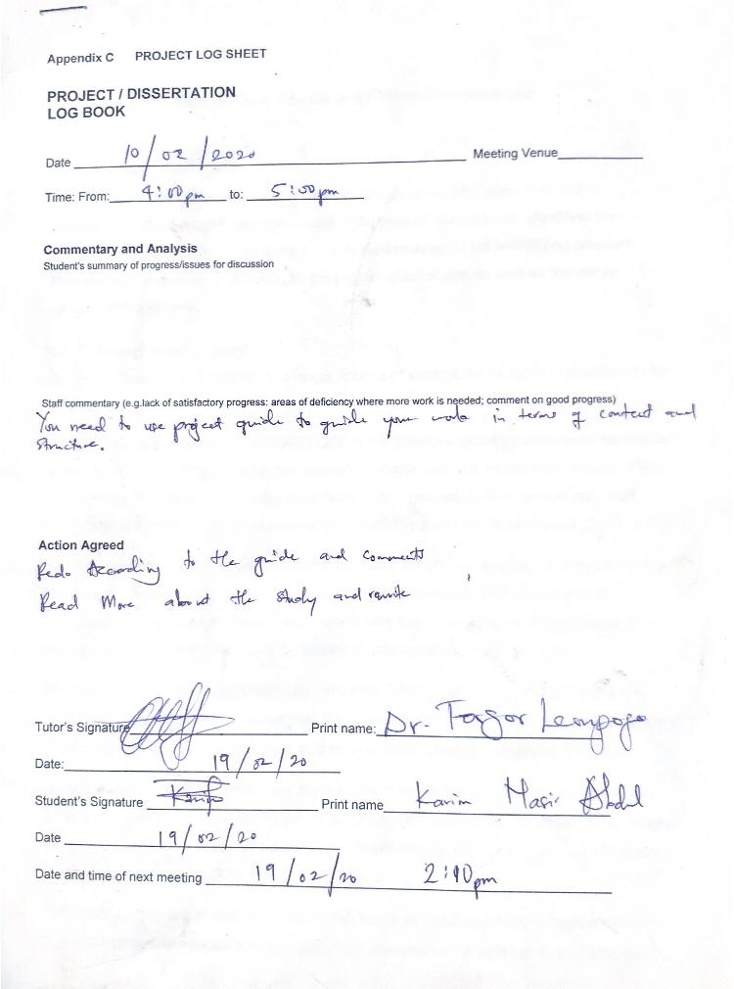

**Appendix B**

Project Implementation Screenshots of Training and Prediction on Azure

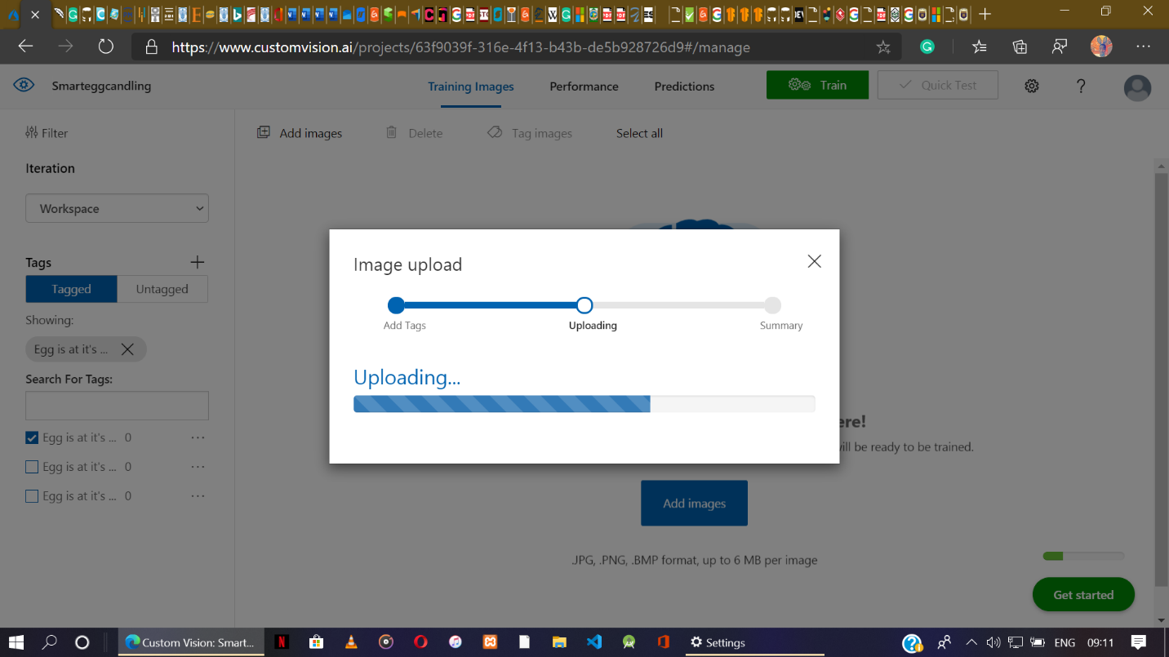

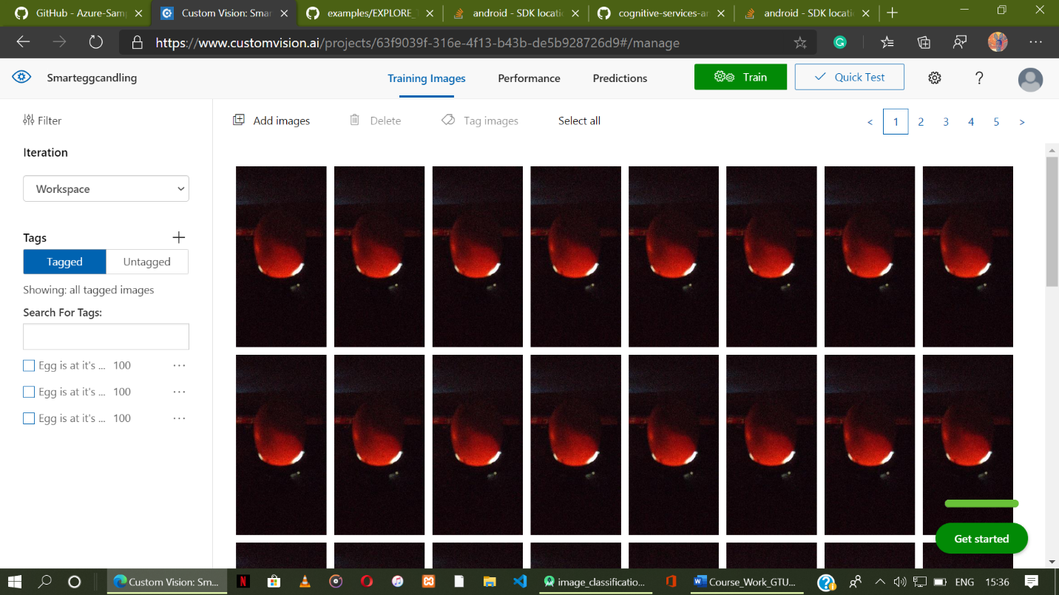

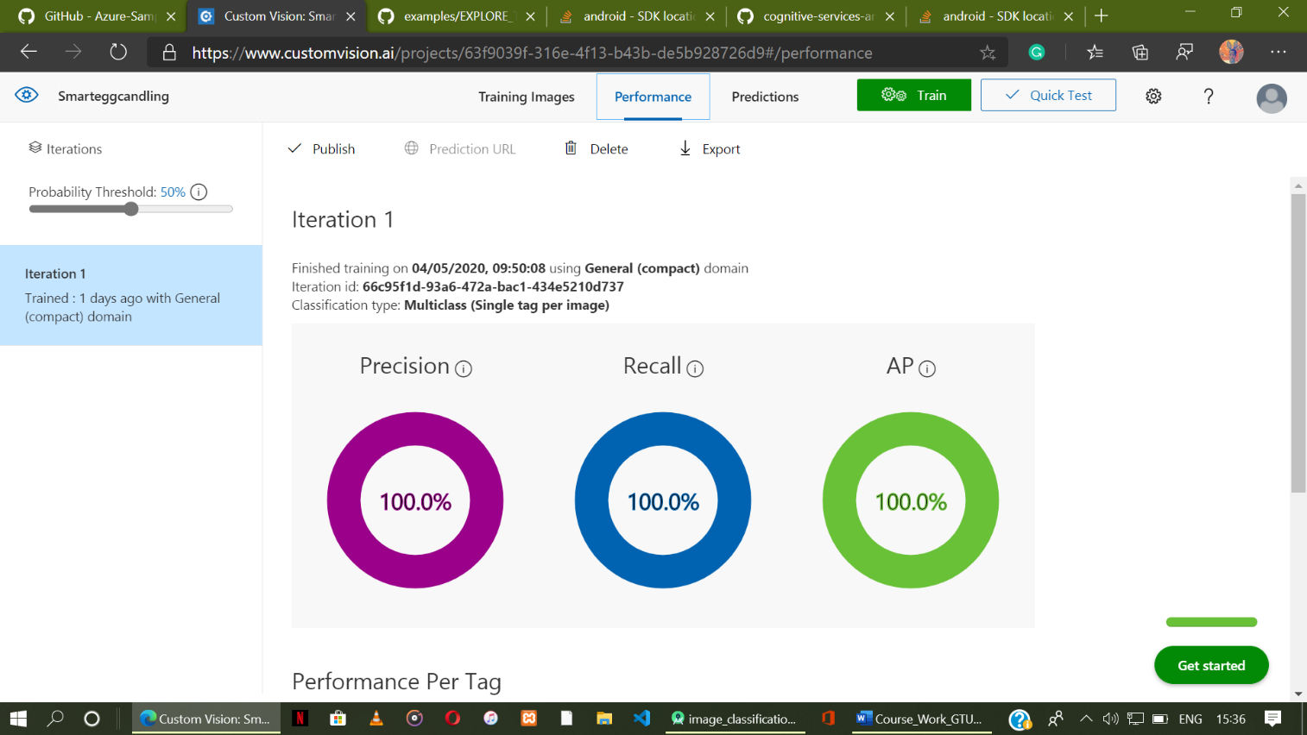

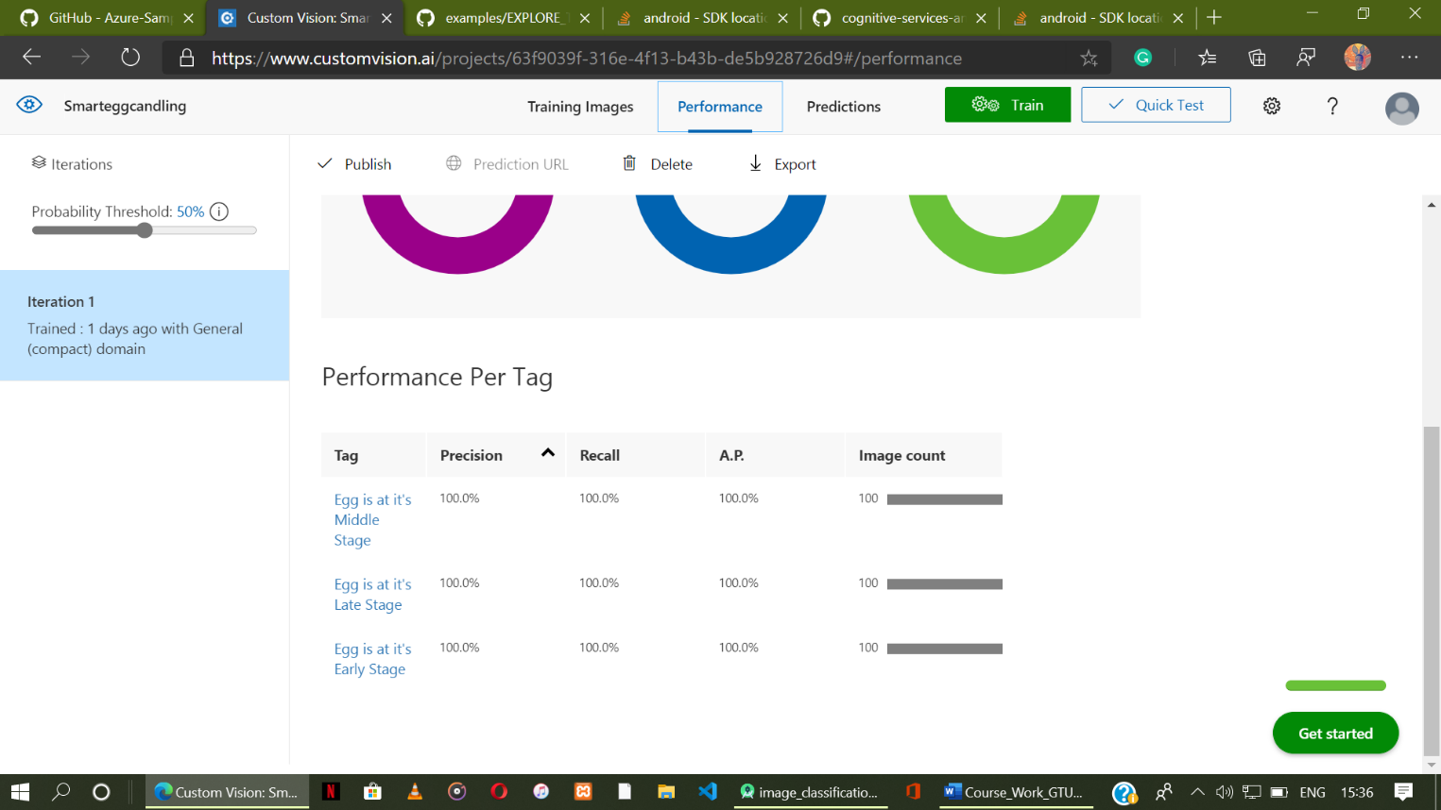

**C.**

**Appendix C**

12 System Usability Scale Questionnaire used for Testing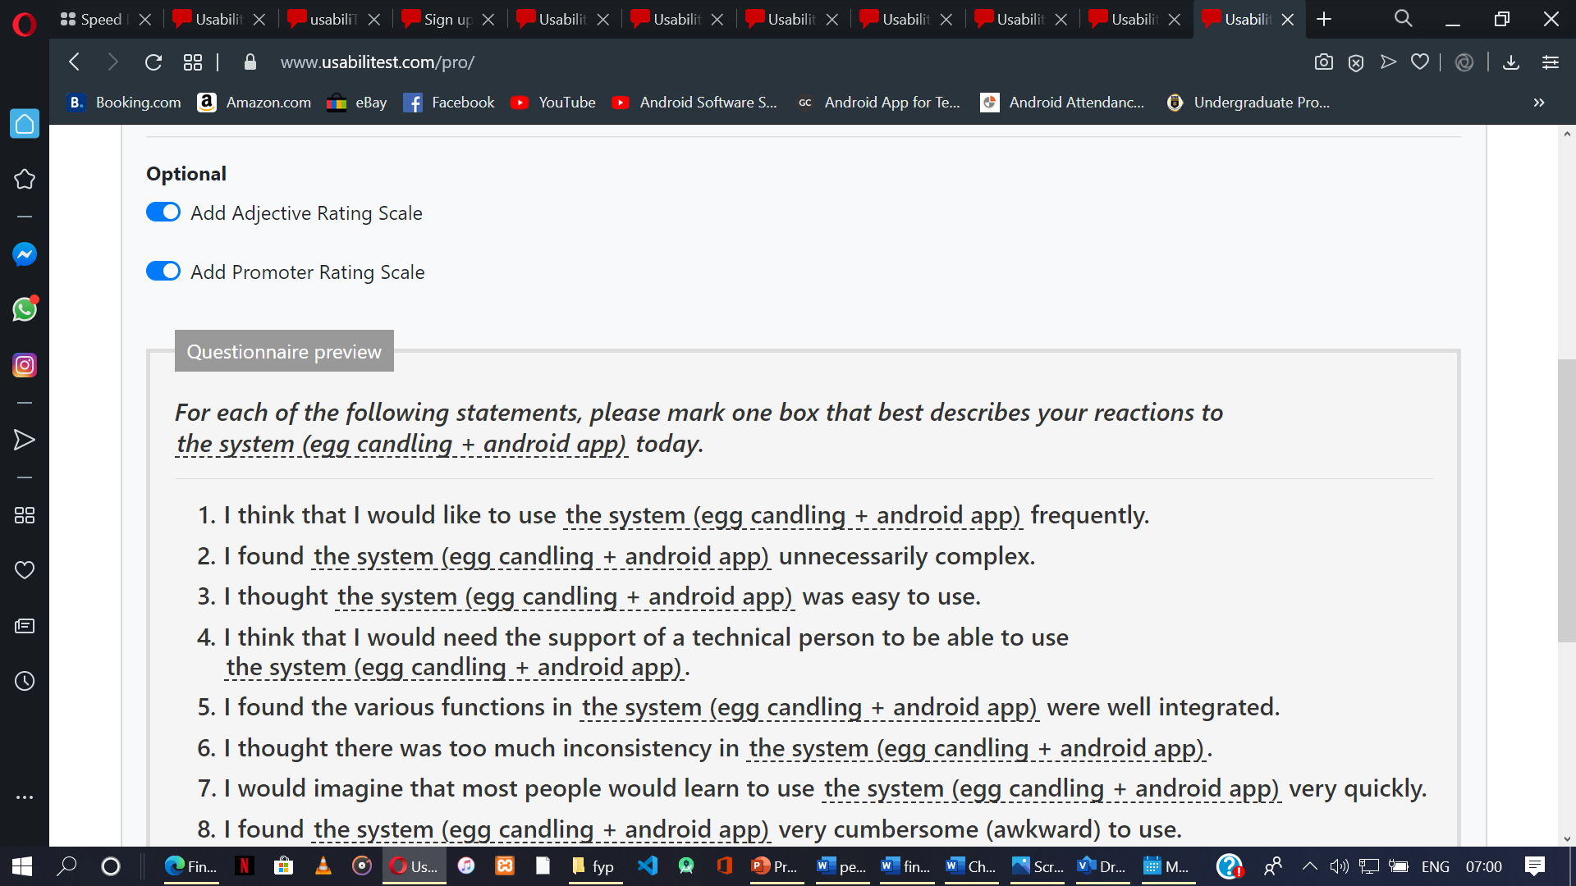

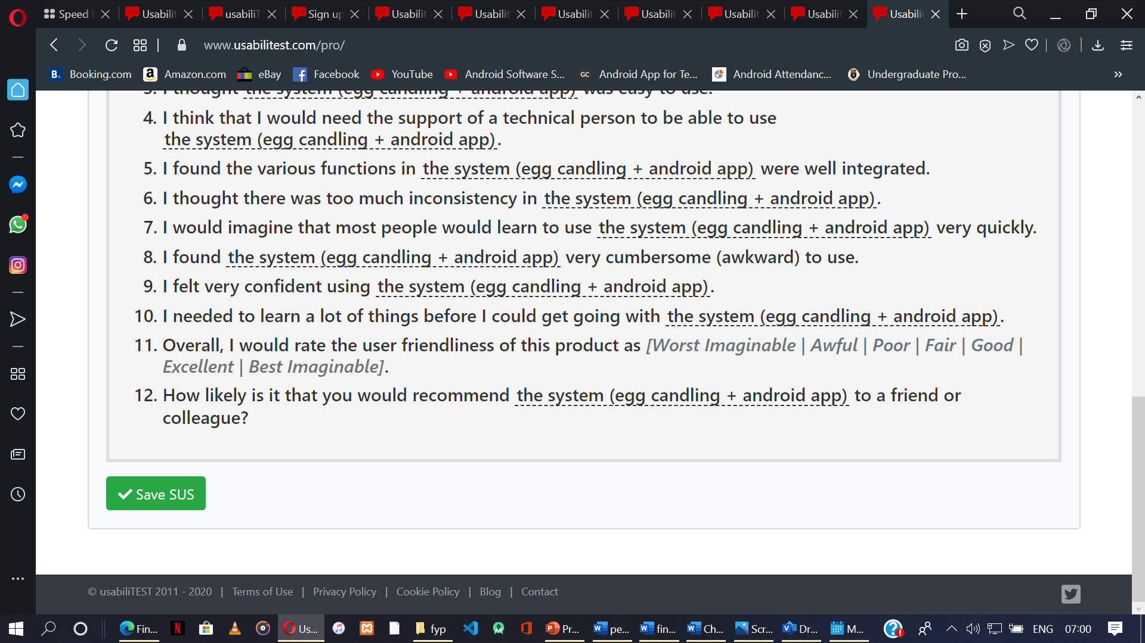

**Appendix D**

User guide to using the smart candling egg candling system

**Steps:**

1. **Prepare Candling Unit.**
   1. Fix Battery
   2. On switch to see if current flow through the candling unit.
2. **Mobile App Setup.**
   1. Install the System’s App
   2. Launch App
   3. Allow permission to use camera (and maybe, Storage)

**General guide to Do Candling:**

1. Insert Egg into the Rubber Ring of the Candling Unit
2. Turn on switch to see a yellowish display of light through the egg shells.
3. Place the back camera of your phone on the Egg illuminated by the candling unit.
4. Wait for an average time of 4 seconds to see egg stage on a label on an android app interface.

**Appendix E**

1. Smart egg app icon



1. 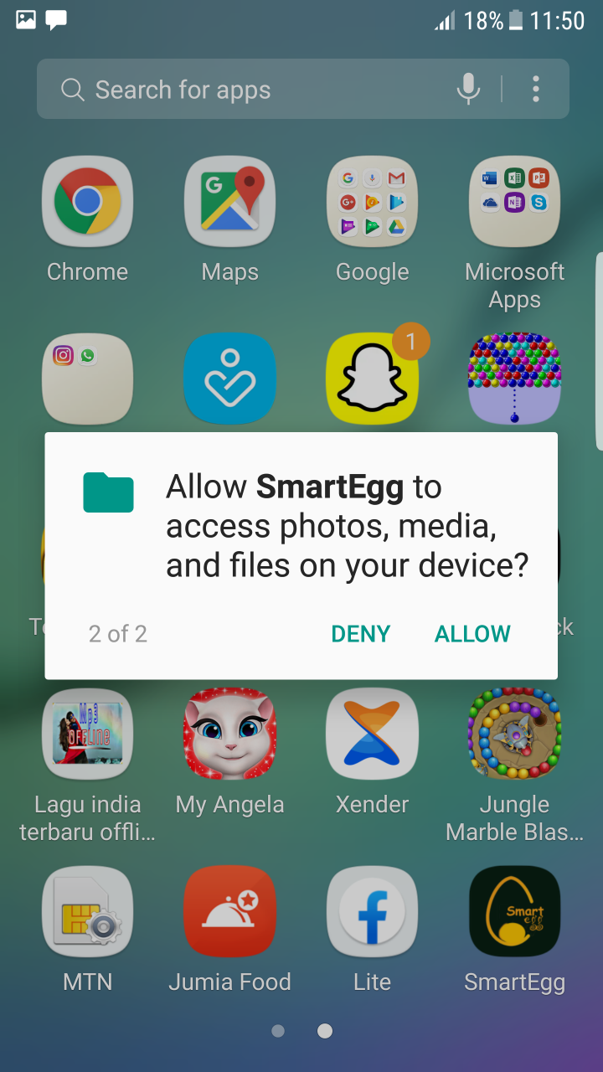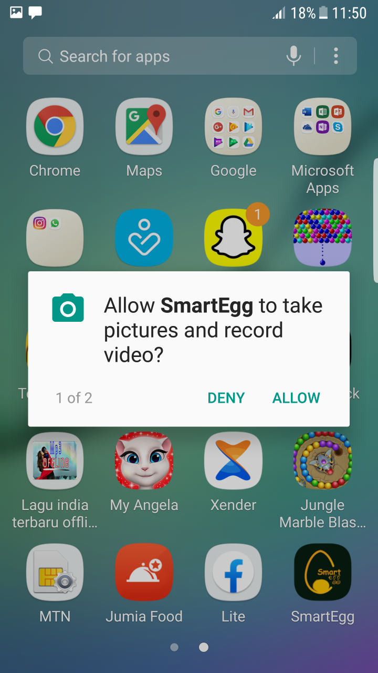Snapshots from the first launch of the SmartEgg App – app permission

**Appendix F**

Sample Code used for creation of the Camera Activity of the android software

package com.candling_system.org.smart_egg;  
  
import android.Manifest;  
import android.app.Activity;  
import android.app.Fragment;  
import android.content.Context;  
import android.content.pm.PackageManager;  
import android.graphics.Bitmap;  
import android.hardware.Camera;  
import android.hardware.camera2.CameraAccessException;  
import android.hardware.camera2.CameraCharacteristics;  
import android.hardware.camera2.CameraManager;  
import android.hardware.camera2.params.StreamConfigurationMap;  
import android.media.Image;  
import android.media.Image.Plane;  
import android.media.ImageReader;  
import android.media.ImageReader.OnImageAvailableListener;  
import android.os.Build;  
import android.os.Bundle;  
import android.os.Handler;  
import android.os.HandlerThread;  
import android.os.Trace;  
import android.util.Size;  
import android.view.KeyEvent;  
import android.view.WindowManager;  
import android.widget.Toast;  
import java.nio.ByteBuffer;  
  
import com.candling_system.org.smart_egg.env.Logger;  
import com.candling_system.org.smart_egg.env.ImageUtils;  
  
public abstract class CameraActivity extends Activity implements OnImageAvailableListener, Camera.  
 PreviewCallback {  
 private static final Logger *LOGGER* = new Logger();  
 private static final int *PERMISSIONS_REQUEST* = 1;  
 private static final String *PERMISSION_CAMERA* = Manifest.permission.*CAMERA*;  
 private static final String *PERMISSION_STORAGE* = Manifest.permission.*WRITE_EXTERNAL_STORAGE*;  
 private boolean debug = false;  
 private Handler handler;  
 private HandlerThread handlerThread;  
 private boolean useCamera2API;  
 protected Bitmap rgbFrameBitmap = null;  
 private int[] rgbBytes = null;  
 protected int previewWidth = 0;  
 protected int previewHeight = 0;  
 protected Bitmap croppedBitmap = null;  
 protected static final boolean *SAVE_PREVIEW_BITMAP* = false;  
 protected long lastProcessingTimeMs;  
 protected Bitmap cropCopyBitmap;  
 protected ResultsView resultsView;

protected boolean computing = false;

**CameraActivity.java**

protected Runnable postInferenceCallback;  
protected byte[][] yuvBytes=new byte[3][];  
protected int yRowStride;  
  
@Override  
protected void onCreate(final Bundle savedInstanceState) {  
 *LOGGER*.d("onCreate " + this);  
 super.onCreate(null);  
 getWindow().addFlags(WindowManager.LayoutParams.*FLAG_KEEP_SCREEN_ON*);  
  
 setContentView(R.layout.*activity_camera*);  
  
 if (hasPermission()) {  
 setFragment();  
 } else {  
 requestPermission();  
 }  
}  
  
*/**  
 * Callback for android.hardware.Camera API  
 */*@Override  
public void onPreviewFrame(final byte[] bytes, final Camera camera) {  
 if (computing) {  
 return;  
 }  
 computing = true;  
 yuvBytes[0] = bytes;  
 try {  
 // Initialize the storage bitmaps once when the resolution is known.  
 if (rgbBytes == null) {  
 Camera.Size previewSize = camera.getParameters().getPreviewSize();  
 previewHeight = previewSize.height;  
 previewWidth = previewSize.width;  
 rgbBytes = new int[previewWidth * previewHeight];  
 onPreviewSizeChosen(new Size(previewSize.width, previewSize.height), 90);  
 }  
 ImageUtils.*convertYUV420SPToARGB8888*(bytes, rgbBytes, previewWidth, previewHeight);  
 } catch (final Exception e) {  
 *LOGGER*.e(e, "Exception!");  
 return;  
 }  
 postInferenceCallback = new Runnable() {  
 @Override  
 public void run() {  
 camera.addCallbackBuffer(bytes);  
 }  
 };  
 processImageRGBbytes(rgbBytes);  
}

*/**  
 * Callback for Camera2 API  
 */*@Override  
public void onImageAvailable(final ImageReader reader) {  
 Image image = null;  
 //We need wait until we have some size from onPreviewSizeChosen  
 if (previewWidth == 0 || previewHeight == 0) {  
 return;  
 }  
 rgbBytes = new int[previewWidth * previewHeight];  
 try {  
 image = reader.acquireLatestImage();  
  
 if (image == null) {  
 return;  
 }  
  
 if (computing) {  
 image.close();  
 return;  
 }  
 computing = true;  
 Trace.*beginSection*("imageAvailable");  
 final Plane[] planes = image.getPlanes();  
 fillBytes(planes, yuvBytes);  
 yRowStride = planes[0].getRowStride();  
 final int uvRowStride = planes[1].getRowStride();  
 final int uvPixelStride = planes[1].getPixelStride();  
 ImageUtils.*convertYUV420ToARGB8888*(  
 yuvBytes[0],  
 yuvBytes[1],  
 yuvBytes[2],  
 previewWidth,  
 previewHeight,  
 yRowStride,  
 uvRowStride,  
 uvPixelStride,  
 rgbBytes);  
 image.close();  
  
 } catch (final Exception e) {  
 if (image != null) {  
 image.close();  
 }  
 *LOGGER*.e(e, "Exception!");  
 Trace.*endSection*();  
 return;  
 }  
 processImageRGBbytes(rgbBytes);  
 Trace.*endSection*();  
}

@Override  
public synchronized void onStart() {  
 *LOGGER*.d("onStart " + this);  
 super.onStart();  
}  
  
@Override  
public synchronized void onResume() {  
 *LOGGER*.d("onResume " + this);  
 super.onResume();  
  
 handlerThread = new HandlerThread("inference");  
 handlerThread.start();  
 handler = new Handler(handlerThread.getLooper());  
}  
  
@Override  
public synchronized void onPause() {  
 *LOGGER*.d("onPause " + this);  
  
 if (!isFinishing()) {  
 *LOGGER*.d("Requesting finish");  
 finish();  
 }  
  
 handlerThread.quitSafely();  
 try {  
 handlerThread.join();  
 handlerThread = null;  
 handler = null;  
 } catch (final InterruptedException e) {  
 *LOGGER*.e(e, "Exception!");  
 }  
  
 super.onPause();  
}  
  
@Override  
public synchronized void onStop() {  
 *LOGGER*.d("onStop " + this);  
 super.onStop();  
}  
  
@Override  
public synchronized void onDestroy() {  
 *LOGGER*.d("onDestroy " + this);  
 super.onDestroy();  
}  
  
protected synchronized void runInBackground(final Runnable r) {  
 if (handler != null) {  
 handler.post(r);  
 }  
}

@Override  
public void onRequestPermissionsResult(  
 final int requestCode, final String[] permissions, final int[] grantResults) {  
 switch (requestCode) {  
 case *PERMISSIONS_REQUEST*: {  
 if (grantResults.length > 0  
 && grantResults[0] == PackageManager.*PERMISSION_GRANTED* && grantResults[1] == PackageManager.*PERMISSION_GRANTED*) {  
 setFragment();  
 } else {  
 requestPermission();  
 }  
 }  
 }  
}  
  
private boolean hasPermission() {  
 if (Build.VERSION.*SDK_INT* >= Build.VERSION_CODES.*M*) {  
 return checkSelfPermission(*PERMISSION_CAMERA*) == PackageManager.*PERMISSION_GRANTED* &&  
 checkSelfPermission(*PERMISSION_STORAGE*) == PackageManager.*PERMISSION_GRANTED*;  
 } else {  
 return true;  
 }  
}  
  
private void requestPermission() {  
 if (Build.VERSION.*SDK_INT* >= Build.VERSION_CODES.*M*) {  
 if (shouldShowRequestPermissionRationale(*PERMISSION_CAMERA*) ||  
 shouldShowRequestPermissionRationale(*PERMISSION_STORAGE*)) {  
 Toast.*makeText*(CameraActivity.this,  
 "Camera AND storage permission are required for this demo", Toast.*LENGTH_LONG*).show();  
 }  
 requestPermissions(new String[] {*PERMISSION_CAMERA*, *PERMISSION_STORAGE*}, *PERMISSIONS_REQUEST*);  
 }  
}  
  
// Returns true if the device supports the required hardware level, or better.  
boolean isHardwareLevelSupported(CameraCharacteristics characteristics, int requiredLevel) {  
 int deviceLevel = characteristics.get(CameraCharacteristics.*INFO_SUPPORTED_HARDWARE_LEVEL*);  
 if (deviceLevel == CameraCharacteristics.*INFO_SUPPORTED_HARDWARE_LEVEL_LEGACY*) {  
 return requiredLevel == deviceLevel;  
 }  
 // deviceLevel is not LEGACY, can use numerical sort  
 return requiredLevel <= deviceLevel;  
}  
  
private String chooseCamera() {  
 final CameraManager manager = (CameraManager) getSystemService(Context.*CAMERA_SERVICE*);  
 try {  
 for (final String cameraId : manager.getCameraIdList()) {  
 final CameraCharacteristics characteristics = manager.getCameraCharacteristics(cameraId);  
  
 // We don't use a front facing camera in this sample.  
 final Integer facing = characteristics.get(CameraCharacteristics.*LENS_FACING*);  
 if (facing != null && facing == CameraCharacteristics.*LENS_FACING_FRONT*) {  
 continue;  
 }

final StreamConfigurationMap map =  
 characteristics.get(CameraCharacteristics.*SCALER_STREAM_CONFIGURATION_MAP*);  
  
 if (map == null) {  
 continue;  
 }  
  
 useCamera2API = isHardwareLevelSupported(characteristics,  
 CameraCharacteristics.*INFO_SUPPORTED_HARDWARE_LEVEL_FULL*);  
 *LOGGER*.i("Camera API lv2?: %s", useCamera2API);  
 return cameraId;  
 }  
 } catch (CameraAccessException e) {  
 *LOGGER*.e(e, "Not allowed to access camera");  
 }  
  
 return null;  
 }  
  
 protected void setFragment() {  
 String cameraId = chooseCamera();  
  
 Fragment fragment;  
 if (useCamera2API) {  
 CameraConnectionFragment camera2Fragment =  
 CameraConnectionFragment.*newInstance*(  
 new CameraConnectionFragment.ConnectionCallback() {  
 @Override  
 public void onPreviewSizeChosen(final Size size, final int rotation) {  
 previewHeight = size.getHeight();  
 previewWidth = size.getWidth();  
 CameraActivity.this.onPreviewSizeChosen(size, rotation);  
 }  
 },  
 this,  
 getLayoutId(),  
 getDesiredPreviewFrameSize());  
  
 camera2Fragment.setCamera(cameraId);  
 fragment = camera2Fragment;  
 } else {  
 fragment = new LegacyCameraConnectionFragment(this, getLayoutId());  
 }  
  
 getFragmentManager()  
 .beginTransaction()  
 .replace(R.id.*container*, fragment)  
 .commit();  
 }

protected void fillBytes(final Plane[] planes, final byte[][] yuvBytes) {  
 // Because of the variable row stride it's not possible to know in  
 // advance the actual necessary dimensions of the yuv planes.  
 for (int i = 0; i < planes.length; ++i) {  
 final ByteBuffer buffer = planes[i].getBuffer();  
 if (yuvBytes[i] == null) {  
 *LOGGER*.d("Initializing buffer %d at size %d", i, buffer.capacity());  
 yuvBytes[i] = new byte[buffer.capacity()];  
 }  
 buffer.get(yuvBytes[i]);  
 }  
 }  
  
 public boolean isDebug() {  
 return debug;  
 }  
  
 public void requestRender() {  
 final OverlayView overlay = (OverlayView) findViewById(R.id.*debug_overlay*);  
 if (overlay != null) {  
 overlay.postInvalidate();  
 }  
 }  
  
 public void addCallback(final OverlayView.DrawCallback callback) {  
 final OverlayView overlay = (OverlayView) findViewById(R.id.*debug_overlay*);  
 if (overlay != null) {  
 overlay.addCallback(callback);  
 }  
 }  
  
 public void onSetDebug(final boolean debug) {}  
  
 @Override  
 public boolean onKeyDown(final int keyCode, final KeyEvent event) {  
 if (keyCode == KeyEvent.*KEYCODE_VOLUME_DOWN* || keyCode == KeyEvent.*KEYCODE_VOLUME_UP*) {  
 debug = !debug;  
 requestRender();  
 onSetDebug(debug);  
 return true;  
 }  
 return super.onKeyDown(keyCode, event);  
 }  
  
 protected abstract void processImageRGBbytes(int[] rgbBytes ) ;  
 protected abstract void onPreviewSizeChosen(final Size size, final int rotation);  
 protected abstract int getLayoutId();  
 protected abstract Size getDesiredPreviewFrameSize();  
}

protected void fillBytes(final Plane[] planes, final byte[][] yuvBytes) {  
 // Because of the variable row stride it's not possible to know in  
 // advance the actual necessary dimensions of the yuv planes.  
 for (int i = 0; i < planes.length; ++i) {  
 final ByteBuffer buffer = planes[i].getBuffer();  
 if (yuvBytes[i] == null) {  
 *LOGGER*.d("Initializing buffer %d at size %d", i, buffer.capacity());  
 yuvBytes[i] = new byte[buffer.capacity()];  
 }  
 buffer.get(yuvBytes[i]);  
 }  
 }  
  
 public boolean isDebug() {  
 return debug;  
 }  
  
 public void requestRender() {  
 final OverlayView overlay = (OverlayView) findViewById(R.id.*debug_overlay*);  
 if (overlay != null) {  
 overlay.postInvalidate();  
 }  
 }  
  
 public void addCallback(final OverlayView.DrawCallback callback) {  
 final OverlayView overlay = (OverlayView) findViewById(R.id.*debug_overlay*);  
 if (overlay != null) {  
 overlay.addCallback(callback);  
 }  
 }  
  
 public void onSetDebug(final boolean debug) {}  
  
 @Override  
 public boolean onKeyDown(final int keyCode, final KeyEvent event) {  
 if (keyCode == KeyEvent.*KEYCODE_VOLUME_DOWN* || keyCode == KeyEvent.*KEYCODE_VOLUME_UP*) {  
 debug = !debug;  
 requestRender();  
 onSetDebug(debug);  
 return true;  
 }  
 return super.onKeyDown(keyCode, event);  
 }  
  
 protected abstract void processImageRGBbytes(int[] rgbBytes ) ;  
 protected abstract void onPreviewSizeChosen(final Size size, final int rotation);  
 protected abstract int getLayoutId();  
 protected abstract Size getDesiredPreviewFrameSize();  
}